

SCHOOL OF ARCHITECTURE, COMPUTING AND ENGINEERING

Computer Science and Informatics Subject Area

**Subtitled Cinema and Deaf Service Web Application**

**Nahiyan Chowdhury**

**U1508767**

A report submitted in part fulfilment of the degree of

BSc (Hons) in *Computer Science*

Supervisor**: Aloysius Edoh**

CN6103

30 April 2018

C

ontents

Chapter 1: Introduction 7

1.1 Aims and objectives 8

Chapter 2: Literature Review 9

2.1 Subtitled Cinema 9

2.2 Deaf Services 11

2.3 Deaf History 12

Chapter 3: Case studies 13

3.1 Deaf Website 13

3.2 Interpreter/Note-Taker service 19

Chapter 4: Implementation 20

4.2 Home page 23

4.3 Subtitled Cinema 25

4.4 Deaf Service 28

4.5 Contact Us 30

4.6 Script Code 32

4.7 Key Functions 33

4.8 Testing 33

4.9 Solved Problems 36

4.10 Tools and Techniques 38

4.11 Positive and Negative aspects of Implementation 38

4.12 Surveys 39

Chapter 5: Evaluation 40

5.1 Problem 41

Chapter 6: Conclusion 42

References 43

Appendix A - Initial Project Proposal 44

Appendix B - Final Project Proposal 46

Appendix C – Project Progress Presentation Slides 48

Appendix D – Project Planning 55

Appendix E – Survey Results 56

Appendix F – Project Poster 60

**List of figures**

Figure 1. Deaf World table 2 (Ethnicity, Ethics and the Deaf-World) 11

Figure 2. Action On Hearing Loss (www.actiononhearingloss.org.uk/) 13

Figure 3. AI-Live (www.ai-live.com/) 14

Figure 4. National Deaf Children Society (www.ndcs.org.uk) 16

Figure 5. British Deaf Association (https://bda.org.uk/) 17

Figure 6. BSL Zone (www.bslzone.co.uk) 18

Figure 7. W3.CSS Templates (www.w3schools.com/w3css/w3css_templates.asp) 20

Figure 8. Stylesheet and Fontawesomecode 21

Figure 9. Background Four images code 21

Figure 10. Navigation Bar 21

Figure 11. Navigation Bar Code 21

Figure 12. Navigation Bar code (part 2) 22

Figure 13. Full size images code 22

Figure 14. Modal image gallery in Script (from W3Schools.com) 22

Figure 15. Footer 22

Figure 16. Footer Code 23

Figure 17. Home Page 23

Figure 18. Home Page (part 2) 23

Figure 19. Background image in Home page 24

Figure 20. Home page code 24

Figure 21. Subtitled Cinema page 25

Figure 22. Eight images 25

Figure 23. Background image in Sutbtiled Cinema page 26

Figure 24. Subtitled Cinema page code 26

Figure 25. Eight images of the movies 27

Figure 26. Modal Image gallery code 27

Figure 27. Deaf service page 28

Figure 28. Deaf service form 28

Figure 29. Background image code in Deaf Service page 29

Figure 30. Form CSS code in Deaf Services 29

Figure 31. Deaf Services Code 29

Figure 32. Deaf Services Code 29

Figure 33. Form code in Deaf Service 30

Figure 34. Contact Us page 30

Figure 35. Form in Contact Us page 31

Figure 36. Footer 31

Figure 37. Background image code in Contact Us page 31

Figure 38. Contact Us page code 32

Figure 39. Google Map 32

Figure 40. Brackets (http://brackets.io/) 38

Figure 41. Project Planning Gantt chart 55

Figure 42. Poster 60

Abstract

The aim of my final year project is to create a website for Deaf people by a Deaf person. The outstanding problem is Deaf people’s lack of access to entertainment that hearing people can easily access. My websites aims and objectives is to provide the Deaf community in London with an in depth and accurate listing of subtitled cinema showings, theatre and events. In addition to this it will aim to provide a service with a link to supply Interpreters and note taker’s to Deaf people. Research will be crucial of all current relevant websites in this area to identify problems within the current websites. Surveys and questionnaires to be filled in by Deaf people will be a means of direct research into what Deaf people want and how they use technology. A history of Deaf people’s use of technology and how it has aided them in the past, an exploration of how Deaf people have always adopted new uses of technology as a direct aid to communication, provide a link to human communication aids such as Interpreters and note taker’s that is simple and quick. Completion of this will result in an accurate and interactive website which is user friendly, continually updated to provide new listings with an up to date use of maps for directions and excellent links to agencies to provide human support. In conclusion, it will fill a gap which is that is Deaf aware which means it is designed specifically so Deaf people will understand it, it is simple on purpose as Deaf people find written English hard to understand, it has limited aims for example to find a film or book an interpreter quickly . It will use up to date technological advances. Websites such as this will be needed until such a time when technology advances enough so that Deaf people will not need film subtitles.

# Introduction

This website is for the use of Deaf, hard of hearing and hearing people. Deaf people have always been at the forefront of technological advances because of their need to communicate visually. This website will aim to become a simple events website with the added bonus of providing where there are cinema or film subtitles available. As well as this the aim is to provide an interpreting or notetaking service which Deaf people use as a communication aid. The aim will be to add this if there is enough time. The way in which this website differs from others is because it will combine all of the above three things in one website. Through supplying subtitled events and interpreters it will give Deaf people the same access as hearing people. The idea for this project comes from my personal experience of being Deaf. Websites and technology are crucial within the Deaf community. Hearing people must remember Deaf people cannot speak or listen on a phone so websites hold a special place for us to get information and meet up. The motivation comes from a need to produce good, clear information that is easily understood by Deaf people.

Upon researching other websites it became clear that Deaf research is a limited area. This revealed a huge gap to be filled and a need for a service such as this. Social inclusion or rather not being included is a huge part of Deaf people’s sense of self and isolation contributing to a lot of Deaf mental health problems.

A website template will be created which will be free and open source. Even though this will be more work it will mean more creative independence. Maps will possibly be included to show cinema directions but this will be dependent on time restrictions. The proposed website will include a link to one or more interpreting agencies using a data base system again, this will be dependent upon time restrictions. A direct access link to a booking system will be added and also a contacts page will be created. The design aims to include eight to ten subtitled cinema places, photos of the cinema will be added along with information and times plus dates. All three elements will be on the home page, buttons will be functional and icons added to the menu bar.

This written work will outline the background reasons this project was chosen, highlight other similar websites, referencing their advantages and disadvantages and how they are different or similar to this proposed website. Through evidence based research this website aims to fill a gap in the market and provide easy access to this leisure facility along with a simple interpreter/ note taker booking service. Personal experience, Deaf history, statistics, case studies and web site research will highlight this.

The implementation will highlight problems and issues that arose and how they were solved. The evaluation will include testing and results and also a summary of what could not be achieved as well as what could. The designed website is a starting point to be added to and improved upon in the future, providing users with an easy pathway in accessing subtitled cinema that has not been achieved before and so closing the gap on social exclusion and aiding a less frustrating experience. It is important as a Deaf man myself to create this website as a final year project as one has to understand the impact of Deaf culture and what this means in relation to the work that has been carried out.

## Aims and objectives

The aim of the proposed website is to fill a huge gap in the market regarding Deaf people’s access to the cinema. Research revealed there is a wide range of mistakes due to not updating websites correctly, misuse of databases or other technical problems. This caused a lot of problems as this was the only source of information available. For example, a film was displayed to have subtitles included but in reality this was often the wrong information, the proposed website will aim to eradicate these issues and inconveniences to Deaf people. The designed website will aim to provide accurate information on subtitled films or events so that this never happens. From personal experience this can be very distressing. It is a common occurrence that Deaf people make special arrangements to turn up for cinema showings often at crazy and inconvenient times only to find that the film is not on at that time or place and is not even subtitled anyway!. This adds to a Deaf person’s sense of exclusion from the hearing world and is also so frustrating and annoying. My Deafness is an advantage to the creation of this website. The reason being that I have directly experienced this happening many times so am aware of the feelings it can create. Therefore, I know what Deaf people want to see in a website such as this and am sensitive to my target audiences needs and feelings.

The objective of the proposed website is to help Deaf people to have the same access as a hearing person in this social situation. There are nine million people in the UK with a hearing loss. This is a large group of people and a huge gap to fill as many of these Deaf people experience social exclusion in their daily lives. The reason behind this websites creation is to lessen Deaf people’s social isolation and achieve the same opportunities as a hearing person. Most people love going to the cinema and this website will aim to make it more accessible for Deaf people through a quick and easy to use service that is Deaf aware.

The hearing worlds are often not Deaf aware even though they try to be. The fact is that most hearing people cannot imagine not being able to hear a tube announcement, a concert, an airport rerouting or a telephone call, therefore lots of exclusion for Deaf people is not done out of malice but out of lack of knowledge or what we refer to as ‘Deaf Awareness’ around Deaf people and their specific problems and culture. Interpreters and note takers are useful and necessary aids for us but when we’re in our own leisure time it is nice not to have another person with you all the time! This is where Deaf people’s use of technology was immediately adopted very early on by Deaf people. It saved money, time and the need to book interpreters. We are an extremely independent group as the majority of Deaf people have a hearing impairment NOT a cognitive one which people often assume as sometimes our spoken voice is distorted and can make people think we have a mental impairment also. We do not! We are exactly the same as hearing people but cannot hear. Therefore the proposed website will include, take note of and be sensitive to all these issues. As a Deaf man I have an inside view of them.

# Literature Review

Of the amount of research linked to Deaf studies most of it is written by hearing people but what appears to be missing is research done by Deaf people for Deaf people. This is what makes this website unique, special and different to others that are on the market. Hearing people have always decided what was in the best interests of Deaf people which they thought was to be taught aurally to access the hearing world. Tactics to stop Deaf people signing was punishment if they were seen to use sign language at school.

Historically, most Deaf people have naturally signed as a way of communication. The theory that Deaf people can ‘lip read’ is a myth. Hearing people have always tried to somehow be superior in the ‘best’ ways of communicating – relevant only in the hearing world. This is why this project is different as being a Deaf man myself creating a website for Deaf people means using my own personal experiences in using websites to find events, subtitled film releases or booking an interpreter. What became clear from this is that there is a huge lack of appropriately timed subtitled performances and no quick and easy way to search where they are being shown.

The lessons learnt from the literature review findings is that many Deaf people due to inconvenience of wrong information and websites that are not Deaf aware, download at home and many do not go to the cinema at all. This is sad, as we all know cinema, film, popular culture and talking about these things is a huge part of growing up. Deaf people due to lack of access are missing out on this, through extensive reading around this topic it was discovered that this is what is happening. This is why being a Deaf man myself contributes to being a good candidate for creating a website such as this.

## Subtitled Cinema

Subtitled cinema and events are crucial for Deaf people. Deaf people have always responded immediately to new technology as it has always been a way to help with their communication needs. Subtitles, not just at the cinema but on TV, internet, YouTube and public service announcements are very important if Deaf people are to take any enjoyment or information from the spoken word.

“Common outings amongst young people are pop concerts, nightclubs, theatre, comedy and music. I accepted a long time ago, that they won’t be available or suitable for me, which severely restricts my social inclusion. Other activities, depending on each circumstance are possible, but only with the right support or adaptation…. Going to the cinema for most people is a common social outing to enjoy with family and friends. Until I was 18, I had only been to the cinema two or three times. Seeing the latest film release or most talked about movie was something my family has always accepted as almost impossible because of the lack of subtitled screenings.” *Subtitled Cinema and Me.* Available at https://Deafunity.org/article-interview/subtitled-cinema-me/ (Accessed 9 April 2018)

Imagine not being able to hear anything, activities that hearing people take for granted; Music, theatre, opera, Disco’s, clubs, human interaction on a social, educational or medical level.

Not being able to hear about what people are laughing about, not understanding what drug a doctor is prescribing for you. Deaf people rely on subtitles as there is still not a lot of access with sign language or interpreters plus Deaf people are only allowed a ‘budget’ for these things. Imagine having to decide whether to use your budget to go to a medical appointment or your child’s parents evening, interpreters are expensive and these are choices that Deaf people have to make that hearing people will never understand. Subtitles mean most Deaf people can understand the spoken word independently without having to use another human being to do so.

Deaf people use interpreters when there are no subtitles. An interpreter translates sign language to spoken word and spoken word to sign. They are used in all situations a Deaf person may need for communication purposes For example Education, business meetings, work place, Doctors, Dentist and any other social scenarios. Sometimes Deaf people would like to be on their own and not have another person sitting with them on every occasion. Imagine as a hearing person having to cope with this every day in your work, college life or confidential appointments. Subtitles allow an element of privacy into their lives without relying on another person.

Americans have found a solution through the use of ‘subtitled glasses’ as an alternative to subtitles www.reDeafined.com, also used are voice recognition subtitles on films but as we know these mostly give the wrong words, due to voice recognition technology not being advanced enough. Through my literature review findings, a continuing theme is that access to the hearing world should be accessible to all.

Here are some Deaf statistics:

Approximately 1 in every 1000 child is born with a hearing loss

90% of all Deaf children are born to hearing parents

Many people who are born with a profound hearing loss form part of the Deaf community. They have their own distinctive language and culture.

There are 50.000 Deaf BSL (British Sign Language) users in the UK

(PDF) <https://www.disability.co.uk/sites/default/files/resources/UKStatistics%26Facts.pdf>

The UK cinema industry is currently investigating 'personal' subtitle solutions that could replace the limited number of separate, segregated, inconvenient shows with thousands of inclusive shows. In the USA, hundreds of cinemas are equipped with 'subtitle glasses'. In Australia, many are equipped with small, seat-mounted screens. These 'access' features are invisible to the rest of the audience. Only the wearer/user sees the subtitles. In theory, any show can also be a subtitled show, making all shows inclusive - accessible to customers with or without hearing loss. A 'personal' subtitle solution could help increase the weekly number of subtitled shows. From 1,200 to more than 50,000. http://www.yourlocalcinema.com/explanation.html (Accessed: 9 April 2018)

The “Deaf World” or “Deaf Culture” as Deaf people often refer to themselves with a capital “D” do not see Deafness as a straight forward disability as most hearing people view Deafness, but simply as a different culture , or ethnic group if you like. Deafness is a group of people who yes, are “different” but who retain much the same wants, needs and access as a hearing person does, for example the same rights to cinema access. The paper below describes this viewpoint and illustrates the overlap of hearing and Deaf culture with a table that brilliantly illustrates this point. Harlan, L. (2005) *‘Ethnicity, Ethics and the Deaf-World’, The Journal of Deaf Studies and Deaf Education,* Volume 10, Issue 3, (1 July 2005), pages 291-310.

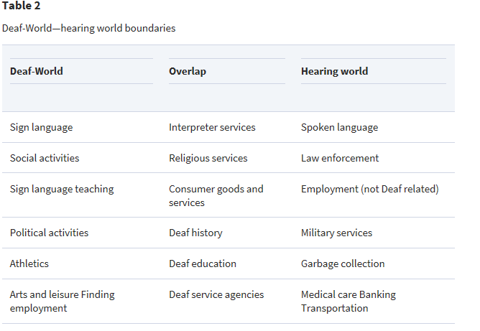

1. Deaf World table 2 (Ethnicity, Ethics and the Deaf-World)

“Four reasons not to construe the Deaf-World as a disability group are advanced: Deaf people themselves do not believe they have a disability; the disability construction brings with it needless medical and surgical risks for the Deaf child; it also endangers the future of the Deaf-World; finally, the disability construction brings bad solutions to real problems because it is predicated on a misunderstanding. (Ethnicity, Ethics and the Deaf-World)

## Deaf Services

In creating a website that provides quick and easy access to films FOR Deaf people created BY a Deaf person who has experienced lack of such access provides a uniqueness to this project.

Equality Act 2010 and Disability

The first requirement is a requirement, where a provision, criterion or practice of A's puts a disabled person at a substantial disadvantage in relation to a relevant matter in comparison with persons who are not disabled, to take such steps as it is reasonable to have to take to avoid the disadvantage. Legislation.gov.uk (2010) *Equality Act 2010*

When I looked at the legislation or law for disabled access it stated that “Reasonable steps” must be taken to ensure Deaf people are not at a “substantial disadvantage”. *Equality and Human Rights Commission* Available at: <https://www.equalityhumanrights.com/en/multipage-guide/three-requirements-duty> (Accessed: 26 March 2018).

The problem with most Deaf services which are offered to Deaf people is that they are not Deaf aware. This means the intention is there but the way it is displayed or the lack of appropriate visual communication means many mistakes are made through communication between the Deaf and hearing person becoming confused. Examples of mistakes made are wrong times and dates. This may happen in the hearing world also but hearing people can hear updates on radio or TV or through friends to correct themselves. Deaf people cannot do this. Tone is often lost or misinterpreted with Deaf people for example irony or sarcasm is taken as a true and literal statement.

This is why any website created for Deaf people must not contain information that can be in any way misinterpreted. The forms to fill in for support via a note taker or interpreter must be simple, easy to use, quick and to the point. Links to the subtitled film showings must be clear and presented in a visual way that will not be misinterpreted. We must remember that for Deaf people English is their second language so any information that is not clear can be totally misconstrued.

## Deaf History

Most Deaf people’s language is BSL, (British Sign Language). English is not their first language and often Deaf people may find it difficult to read due to this but subtitles are still a help. Sign language has a very long and rich history- the very first record of sign language dates back to 5BC. (British Deaf Association (2018) what we do/BSL History. Available at http://old-bda.org.uk (Accessed: 5 April 2018).

Language is a total barrier for Deaf people if no subtitles are offered. Hearing people cannot even imagine this, not hearing any information in a hearing world is difficult but cinema is for pleasure and a way to spend free time, to relax, yet access here is blocked as well.

BSL was finally recognised as a language on 18th March 2003 by the British Government. (British Deaf Association (2018) what we do/BSL History. Available at http://old-bda.org.uk (Accessed: 5 April 2018). The Deaf population have a higher instance of mental health problems due to isolation and frustration. That is why a website like mine is of upmost importance. Nine million people in the UK have a hearing loss this is a bigger problem than people assume. When Deaf is spelt with a capital ‘D’ and not a small ‘d’ it means that the Deaf person is recognising themselves as part of a different subculture and is proud to be Deaf.

So how does my knowledge of Deaf history and being in the Deaf world and a part of Deaf culture have relevance to this website? Deaf people are visual so use web pages in very specific ways. We are not interested in audio but as we think visually we want to find what we are looking for very quickly. As BSL (British Sign Language) is our first language and it has a different structure to English we find long chunks of written English difficult to read. We want quick visual information that is not disguised within paragraphs of written text.

We cannot use the phone unless an interpreter does it for us so we love websites with just a simple emailing process. A simple form with no complicated English grammatical techniques which can confuse Deaf people, for example, double negatives or idioms. When you tell a Deaf person an analogy or idiom such as “Its water off a ducks back”, a Deaf person would actually look for the duck in real life. Sign language is very literal so this is reflected in a simple use of forms and English in my website design. Questions regarding booking an interpreter must be simple and clear.

Deaf people love the live chat feature of most product selling websites now as you can ask the questions you would normally ask over the phone immediately and with a real time answer. This will be a feature of the proposed website in the future.

# Case studies

The initial research when starting this project found a definite lack of websites aimed only at subtitled cinema. Below I will show five different websites included in the research, showing the strengths and weaknesses of all and how they compare to my website.

Lists of the five different websites are:-

Action On Hearing Loss

AI-Live

National Deaf Children Society

British Deaf Association

BSL Zone

## Deaf Website

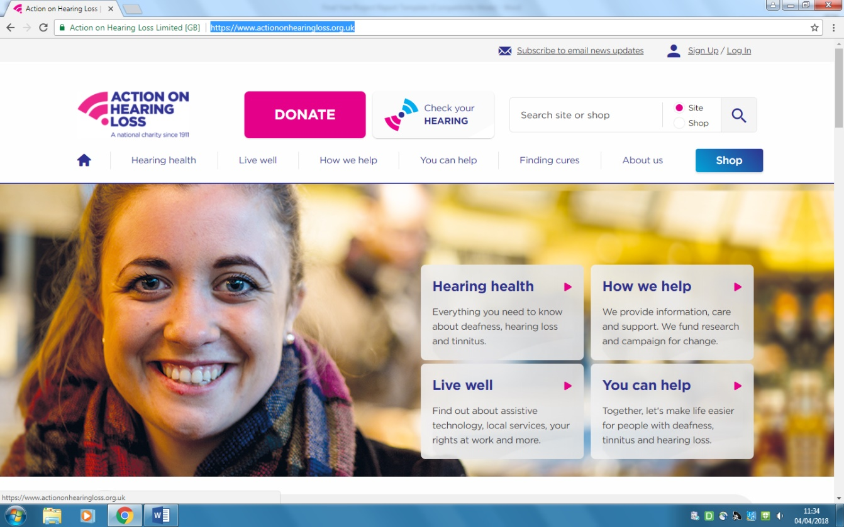

1. Action On Hearing Loss (www.actiononhearingloss.org.uk/)

Action on Hearing loss is a general website for Deaf people. It’s positives are it contains a lot of useful information for the Deaf community. It has government funding so involves lots of affiliated companies. This would not be an option for my website but a future goa for me would be to involve other companies and apply for government grants.

As this website is generic it cannot contain direct links to interpreting agencies as this would be advdertising. It can only give general advice.

This website has no subtitled film options for Deaf people. A definie strength of my website is how specific it will be. It will focus on two problems to be solved.

Finding subtitled films for a specific audience

Finding possible interpreting services

Both these websites are for the Deaf community but in different ways. My website is not trying to do too much because it could make Deaf people confused as their second language is english and lots of Deaf people find written english hard to read. Because of this the website has simple english and instructions and the forms to book an interpreter or find a film showing are purposefully very simple. It is taking a specific problem (lack of cinema access for Deaf people) amd solving that in a specific and up to date way.

My website contains no charity information, affiliated companies or advertising or generic fund raising events. It is a ‘one stop shop’ for people to simply find up to date information on where they can see a subtitled film if they are Deaf.

The single minded aim of my project is it’s defining strength- simplicity and being Deaf aware which means useful to the Deaf community. Deaf aware means something is designed to correspond with how a deaf person thinks/ reads/ lives. Some websites today try to do too much thereby losing the focus of what their original aim is. I feel this website is one of those. It is extremely useful but if I was a Deaf teenager simply wanting to see the latest horror film I would not find it here!

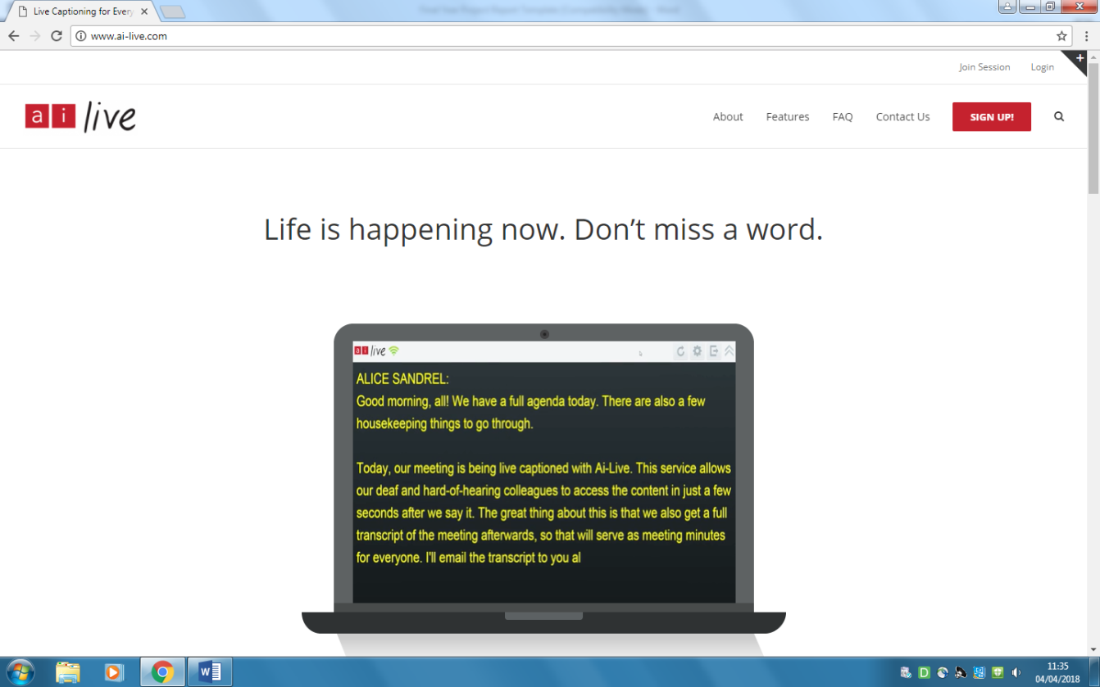

1. AI-Live (www.ai-live.com/)

The AI-Live website focuses on voice recognition technology as a communication aid for Deaf peeple. It explains how the newest voice recogntion software can transmit information from a meeting, lecture or a show directly to the Deaf person through a laptop. This is an incredibly expensive aid.

This is an information website aimed at work or education not leisure. It is specific only to Deaf people who have a budget for such an expensive communication software. For example ‘Accesss to Work’ and ‘DSA’ (Disability student allowance). This website is for Deaf people in work or Deaf students. Budgets are an important issue in the lives of many Deaf people especially due to te recent goveernment cuts as this allowance can impact on a Deaf persons life at home and at work/education. For example a Deaf person is given a budget for a yearly amount of time. It is never enough to cover everything a Deaf person needs an interpreter for. Therfore, Deaf people are put in the incredible difficult position of choosing the most important events that they can have communication access to. For example is my Doctors appontment more inportant than a work meeting? Imagine in the hearing world even having to make these difficul life decisions due to to being Deaf. This is why ‘free’ subtitled cinema access is so important for social inclusion. The aim of my website is to just do this in a very simple way. It will be an easy to use ‘fun’ website, ‘free’ therefore, not involving budget restrictions.

This website has to involve other humans which is expensive and time consuming. My website will be free and cheap to run and will involve minimal human work load apart from updating the database.

This website contained too much detail and it was difficult to find information.

My website is unique in that it has the following listed below:-

Free

No specialist software needed

Need laptop only

Subtitle and film specific

No need to include budget restrictions

Minimal work load to update

Requires no other human involvement

No funding needed

Simple

Quick

Fun

Easy to find information

My website is for all Deaf people and it is implemented in Chapter 4. It is simply a leisure facility. My websites singleness of purpose is it’s main asset. This technology would not be of benefit in a cinema environment as to use this technology one must use a laptop or phone which would not be pernitted in cinema spaces. Although, this website does show me how we all must consider the rise of voice recognition technology in computer science and how to accomodae it into our own websites.

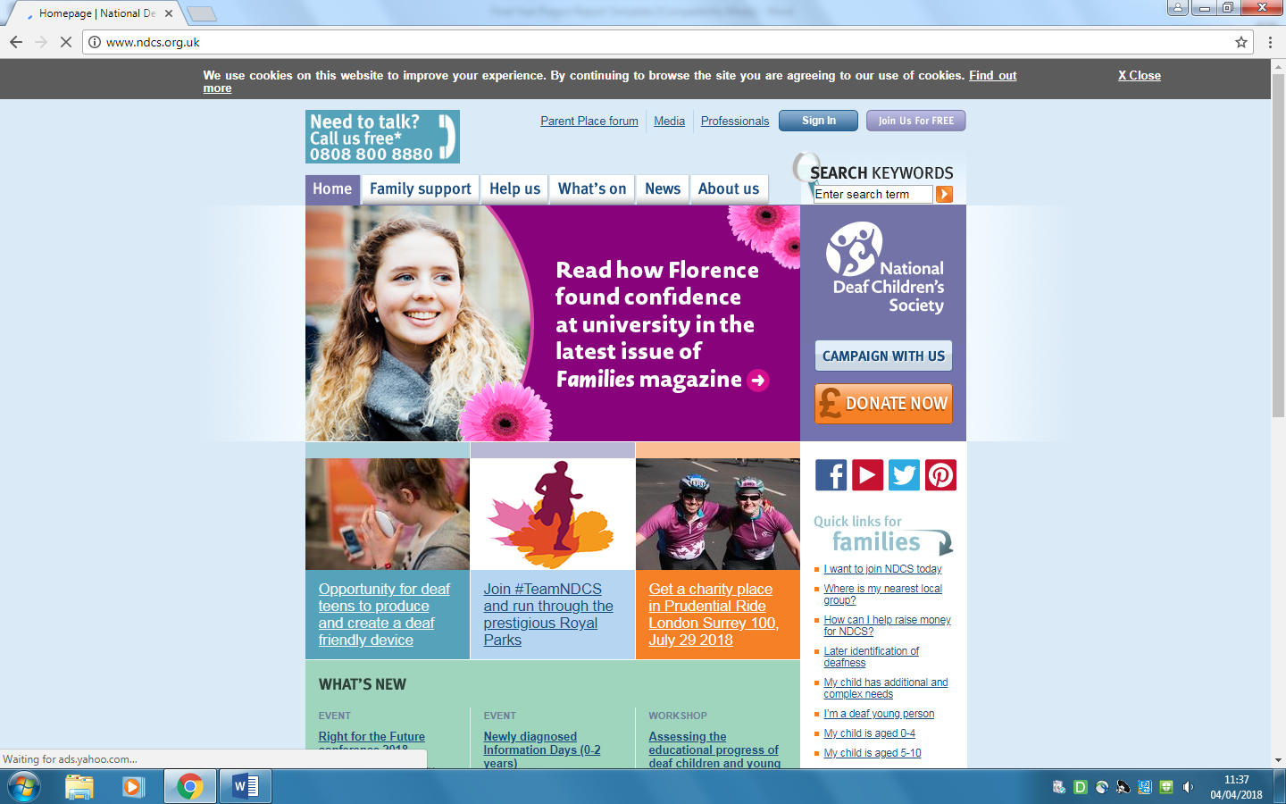

1. National Deaf Children Society (www.ndcs.org.uk)

The National Deaf Children Society is a well known Deaf website, it is a resource that many parents use for their Deaf children. Again, like the other websites it contains a lot of generic information about specific Deaf related events and information. This is an advantage for general Deaf issues but not specific for film subtitles. Although, this website does contains a link to cinema showings which are cineworld and vue these are often out of date and to find the subtitled links took a long time due to the amount of information on this website. For example I managed to find it after approximaely five minutes but I road tested it on two hearing friends that are not as computer literate as myself and they could not find the information at all.

As can be seen in my survey there is a large difficulty around subtitled viewings for Deaf people to access which my website aims to eliminate. When you view subtitled cinema showings three things become very clear. Firstly, they are at obscure times in the afternoon or mornings suggesting Deaf people do not go to work. Secondly, when Deaf people do actually go even at these obscure and unsociable times the listings are often incorrect because of this most Deaf people give up going to the cinema and download at home if they are able to. Thirdly, much to the dismay of most of my Deaf friends they are often out of date anyway! I hope through my website that it may collect enough people who will use it and therefore influence an improvement to these issues.

The advantages to NDCS website is that you can book tickets directly with the cinema, my website does not offer this option at the present time but it is my aim to include this in the future. Again, this website shows the specificness of my website in that it has one aim and will be quick and easy to use. The information will be easy to find and will contain no mistakes eliminating the frustration for Deaf people, as I myself have experienced many times being a Deaf man.

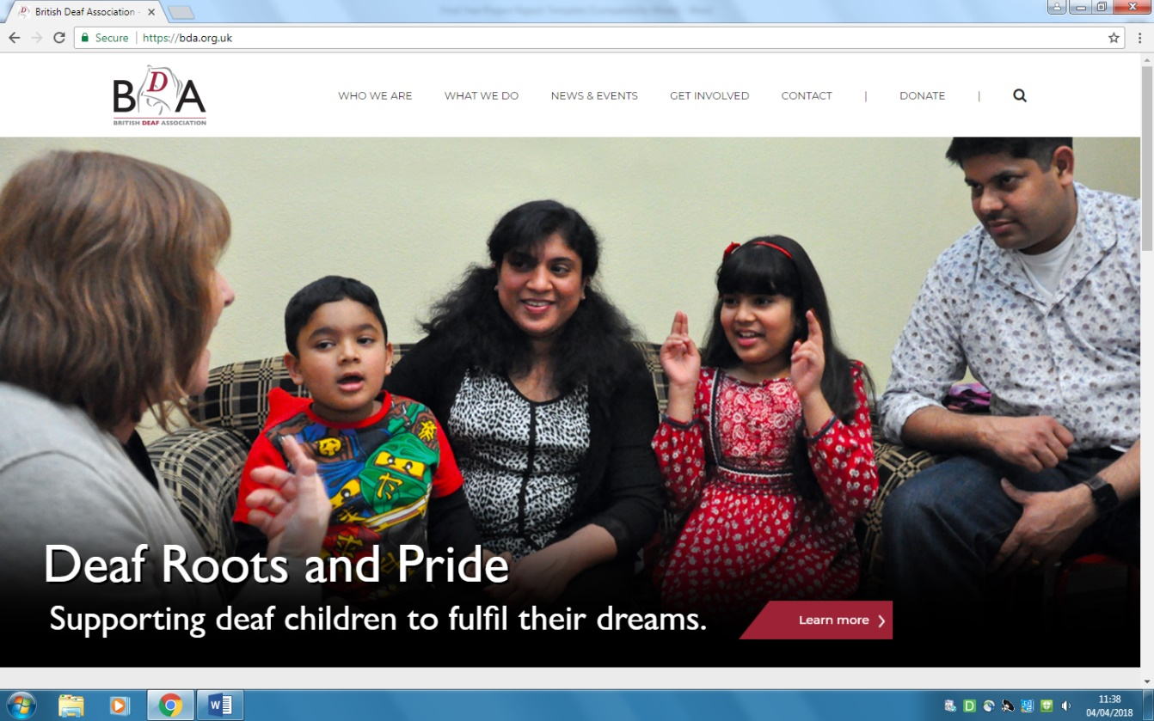

1. British Deaf Association (https://bda.org.uk/)

The British Deaf Association is another famous Deaf website and again it contains a mixture of general information into Deaf related issues. This is not a specific website aimed at leisure such is mine. This is a ‘serious’ website containing information on education, support, Deaf community, resources and fund raising events. These are vital to Deaf people’s live but this is missing what my website aims to do providing leisure and fun which is easy to find and up to date. My website is for leisure there does not appear to be another website that is solely based on this idea.

Even though both our websites are based around the same sort of thing providing information for Deaf people. My website is more inclusive and not focusing just on Deaf activities, my aim is to help Deaf people to have the same access to a leisure facilility that hearing people have. The cinema is enjoyed by a Deaf and hearing audience and should not be excluded to Deaf people in this world of technolgical advances. Deaf inclusion into the hearing world is one of the aims of my website.

This website is well establised and has many contacts to aid it’s functionability, this will be an aim of mine in the future once it becomes established and well known. More access will be gained in the future to more Deaf companies and resources.

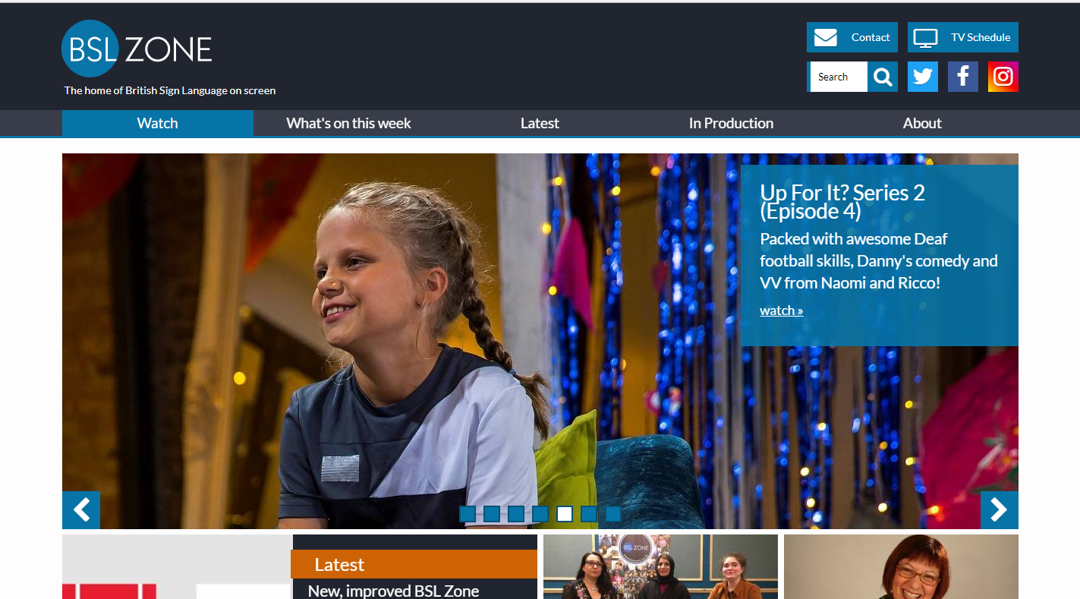

1. BSL Zone (www.bslzone.co.uk)

The BSL Zone website is excellent in that it tells Deaf people which shows on Television are signed. Also specific programmes made including Deaf actors using sign language. It is for Deaf sign language users. There are 50.000 Deaf BSL (British sign language) users in the UK. This is a different type of website as to the proposed website in that mine is specific to film only. It’s singularness of purpose is an asset. The proposed website is for Deaf people who can sign, read and lipread it is all inclusive, It is also specifically designed to access the latest films showing in the cinema to aid inclusion and close the gap on social isolation. Even though both websites are for the Deaf community they have different aims and objectives. This website also contains lots of other information surrounding Deaf issues whereas the proposed website is a quick and easy service looking for a specific subtitled film to watch.

## Interpreter/Note-Taker service

The biggest way for Deaf people to communicate in the modern world is through interpreters and note takers. What do these people do? A note taker can be either manual or electronic and writes down what a Deaf person cannot hear. Hearing students can write and listen at the same time but a Deaf person can only either write, look at the board or look at an interpreter, they cannot multi task in the same way. An interpreter converts sign language to English and vice versa. Some Deaf people have no voice or choose not to use their voice as the different sounds some Deaf people make means people assume they have a cognitive disability also. So an interpreter will translate sign into voiced English to be received by a hearing person and spoken English voiced by a hearing person back into sign to be received by a Deaf person. Interpreters are used by Deaf people for business meetings, access to work – interpreters who are employed to interpret a Deaf persons working daily life, medical, therapeutic and personal needs.

This website will include this service and provide a link where Deaf people can book an interpreter or note taker directly. Although not linked to the subtitled film showings part of this website it will be an added service. Again being a Deaf man who uses these services all the time makes this website unique as I know the difficulties involved. Deaf people cannot use the phone which is a big barrier when booking services or needing information. A website designed for Deaf people must always take this into account in its tools and menus used as a Deaf person can only be contacted by text, emailed or communicate through text phones or hearing loops. This is a part of Deaf world that Deaf people know very well and being a Deaf man makes me ideal to create such a website as this way of communicating is second nature to me.

# Implementation

Based on the case studies carried out there appeared to be a gap in the market for a simple website for Deaf people who wanted to watch films at the cinema that are subtitled. There are lots of Deaf websites on the market but these contained lots of information regarding Deaf culture, education, funding, news, charities and Deaf events. There were none that supplied a simple service that would give Deaf people quick information as to where they can find subtitled film showings in the London area. Any websites that were designed to advertise film showings were always inaccurate or just provided a link to a generic cinema group.

This website is a Deaf website. It shows subtitled film showings so that Deaf people can attend the cinema in London and understand what is happening. This idea is combined with a service where Deaf people can book an interpreting or notetaking service. There are eight subtitled film showings, the aim for the future is to get up to ten or fifteen subtitled films. The menu has been created so that when clicked on a button the page drops down. Each button opens a separate page as shown here – for example, ‘id=home’ link to ‘#home’.

Page jumps are a good way to enable people to move around quickly inside a long page. Time constraints meant prioritising Photoshop skills was not in my schedule. An invaluable lesson in the creation of this website was realising what was important and what was not. Some W3School code will be left in the proposed website and the code will not be edited so there is no need to screen print the coding. The rest of the codes are explained.

Firstly, a free template was used (w3schools.com) this website was used because it was free. For the website design Font Awesome website was used to create the icons for the buttons. Three photos were used, two from a free website (Pexels.com). One photo was a real life photograph taken by myself of my interpreters hands whilst signing. An editing tool was used to merge three photos into one for the background. A problem arose here as Photoshop is not within my skill base at the moment. The three photos were combined using Photojoiner.net this was a quick and easy way to join photographs.

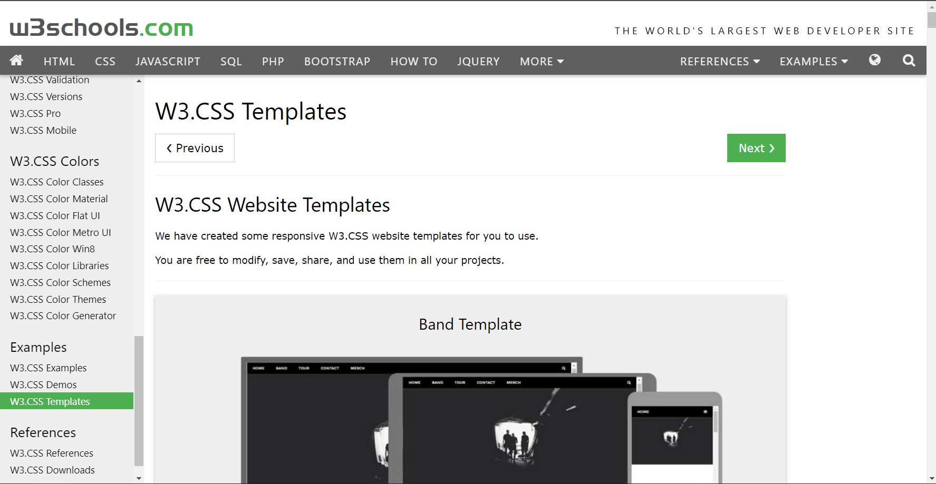

1. W3.CSS Templates (www.w3schools.com/w3css/w3css_templates.asp)

### Stylesheet and fontawesome code

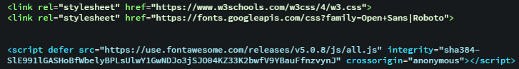

1. Stylesheet and Fontawesomecode

I wanted to use w3shool’s CSS templates so I could use the stylesheet link- because w3school owns I was free to modify and use it for this project. It was decided that I use the font ‘Roboto’. Also font awesome icons for the Navigation Bar. It is free to use them for anything.

### Background images (style)

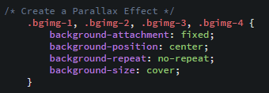

1. Background Four images code

Four images were used, homepage, subtitled cinema, Deaf serivce and contact us in the proposed website. They needed to remain central and the background size to be appropriate when scrolled so that the images move. Repeated images were not to be though it started to repeat both vertically and horizontally. Normal images were needed in the pages such as homepage, subtitled cinema, Deaf serivce and contact us. I used ‘fixed’ in the background-attachment’ that created a fixed background image that will disappear slowly on a scroll. ‘bgimg’ are images, for example, bgimg-1 is for homepage, bgimg-2 (subtitled cinema), bgimg-3 (Deaf service) and bgimg-4 (contact us).

### Navigation Bar



1. Navigation Bar

W3school’s CSS was used for the navigation bar. The button names were changed such as home, subtitled cinema, Deaf service and contact us. I wanted to include the fontawesome icons in the navigation bar as well.

#### Source Code

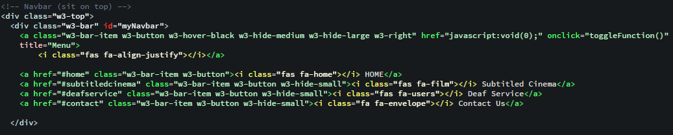

1. Navigation Bar Code

This is for desktop and a tablet screen usage. The navigation bar needed to stay at the top of the webiste when on scroll. It would be hiden when on homepage but can be used to scroll and then it would appear. I made the pages link to the buttons and used ‘#home’, #subtitledcinema, ‘#Deafservice’ and ‘#contact’ because it would jump to other pages, for example ‘id=home’ in homepage code that can be clicked and subtitled cinema in the navigation bar then jumps to the subtitled cinema page. These were included in the Fontawesome icons. Searched icons include home, subtitled cinema, Deaf service and contact us page in the navigation bar. These can be copied and pasted, each of these codes such as ‘<i class="fas fa-home"></i>’ after the titles.

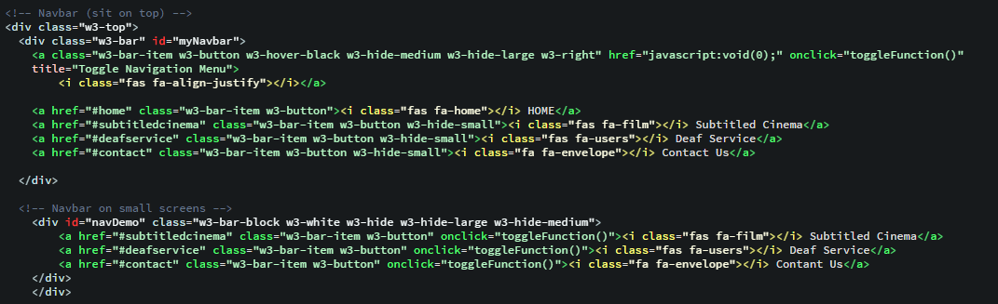

1. Navigation Bar code (part 2)

This is for the mobile screen, the normal navigation bar from a desktop tablet screen would be hidden and would change when you are on a mobile phone. In the desktop or tablet, the navigation bar uses horizontal but whenever you are on the mobile phone, it would change to responsive.

### Full size images (Source Code)

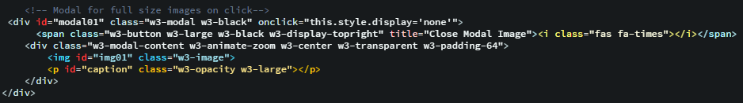

1. Full size images code

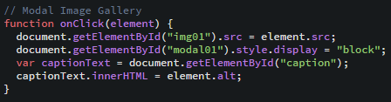

1. Modal image gallery in Script (from W3Schools.com)

### Footer

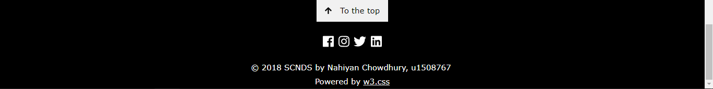

1. Footer

The same colour was kept in the footer from w3school’s CSS. Fontawesome icons were used for the social network logos. You can click ‘To the top’ button, it sends you back to homepage.

#### Source Code

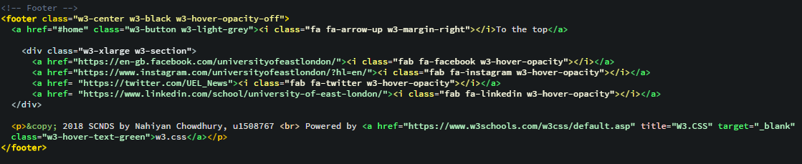

1. Footer Code

It was decided to keep the colour in the footer because it looks quite nice. ‘To the top’ button was added by including the Fontawesome icon which is an arrow up. The UEL, University of East London address was used and added social networks such as Facebook, Instagram, Twitter and LinkedIn from fontawesome as well. You can see ‘&copy;’ that means copyright symbol and ‘<br>’ also means a single line break. W3school websites was kept.

## Home page

Contains a description of the website and services.

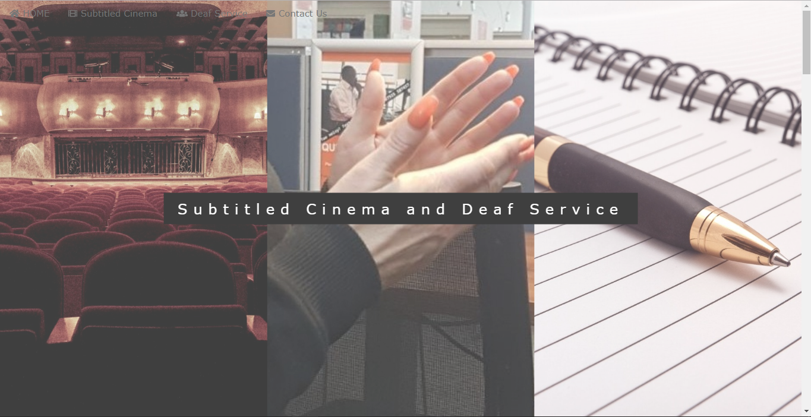

1. Home Page

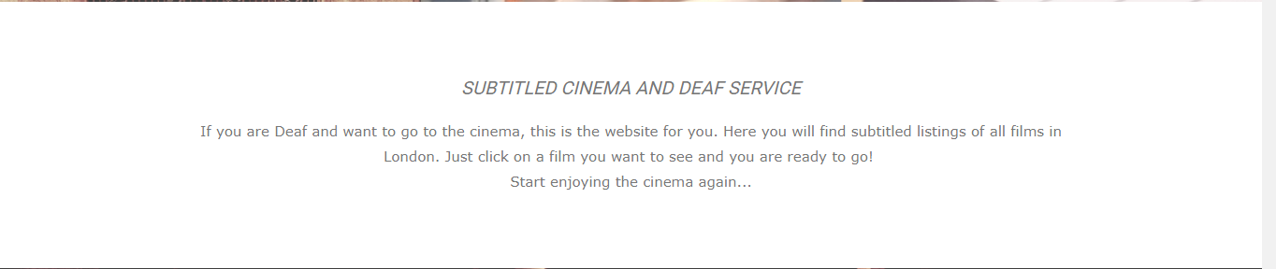

1. Home Page (part 2)

This is the homepage when people immediately go on the website. Combined images were added in the background with a title and some small information which was used from w3school’s CSS.

### Source Code

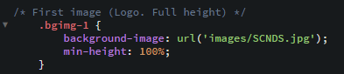

1. Background image in Home page

Three images were used such as cinema, a picture of my interpreter, a live picture (my own) and then they were combined into one image by using www.photojoiner.net and this was then used for the background. The size changed to 100%.

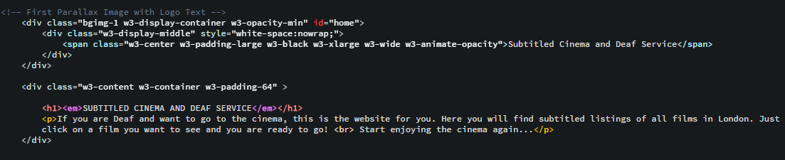

1. Home page code

## Subtitled Cinema

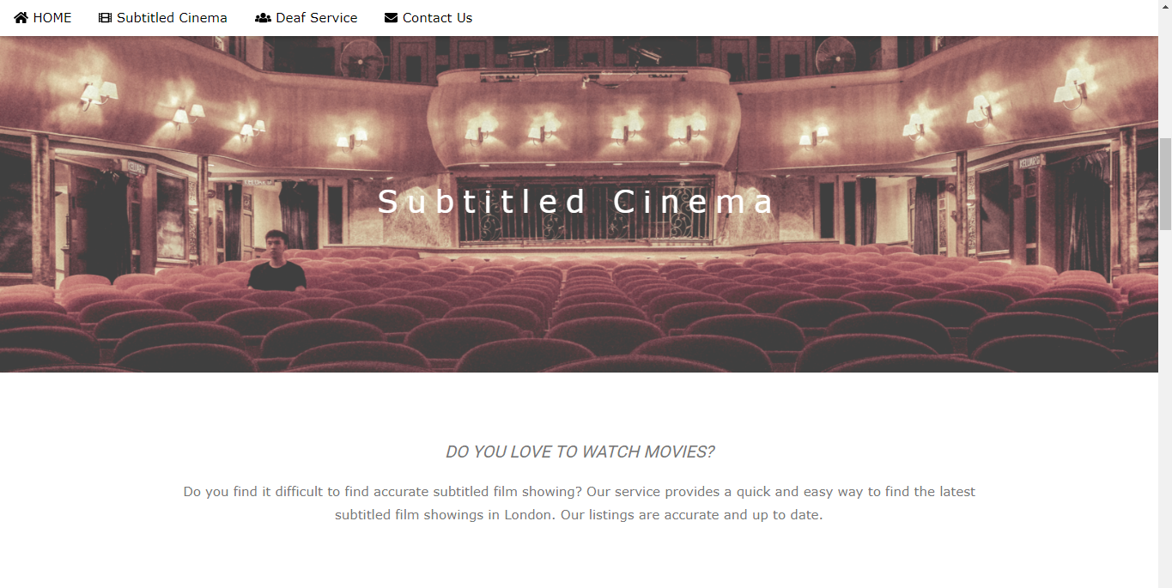

1. Subtitled Cinema page

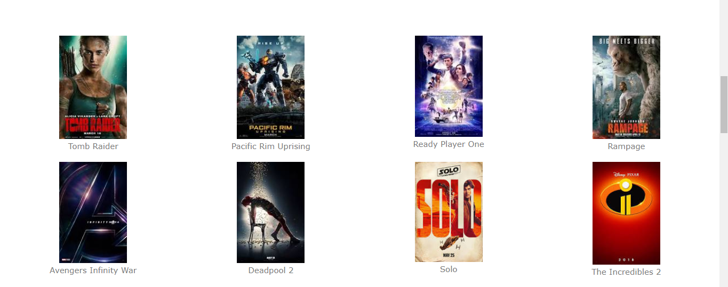

1. Eight images

The background is a real life picture of a cinema. Below the title there are some questions to the audience inviting them to use the website. The adverts for films were found by a simple google search. In the future the intention is to use real examples of films that will be continuously updated. When a film image is clicked times and listings will pop up. The aim is to include a map (Google) in the future but due to time restraints this option is not available as yet.

There are eight images of the movies in the subtitled cinema. Modal images will be used in the gallery so that people can click on these images and it would show up. This function again was used in the script from the w3school website. Some issues arose regarding adding some information such as the date and places. This will be rectified before demonstration day.

### Source Code

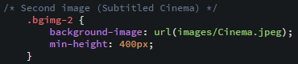

1. Background image in Sutbtiled Cinema page

Cinema image was used for background. Size changed to 100%.

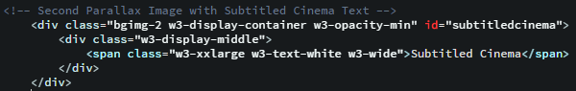

1. Subtitled Cinema page code

Background image contains a title, ‘id= “subtitledcinema” which has been linked with subtitled cinema so when you click on it you are sent to the subtitled cinema page.

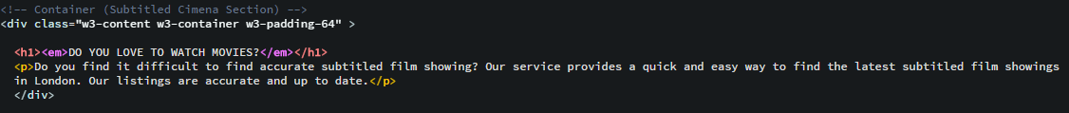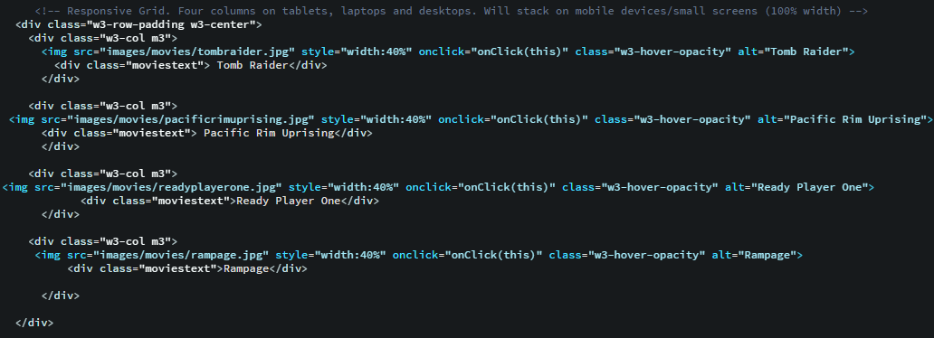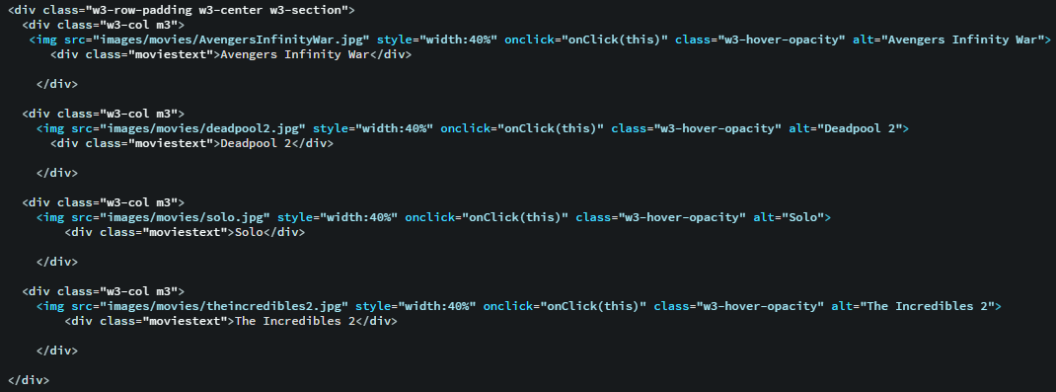

1. Eight images of the movies

‘<em>’ means emphasized text. Eight images of the movies were used but it was decided to use four images in a row so I made them stay cental. Four imageswere added in a row as well. img src linked each image to the correct file. Saving the images in the wrong file means it would not work. The width used is 40% because it looks clear but really small on the desktop. ‘<div class= “moviestext” >’ was used. ‘moviestext’ was used in style to make the title stay central and below the images movie titles were added in alt which means alternate text for an image, for example, alt= “Tomb Raider”.

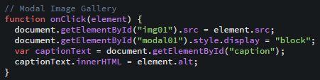

1. Modal Image gallery code

## Deaf Service

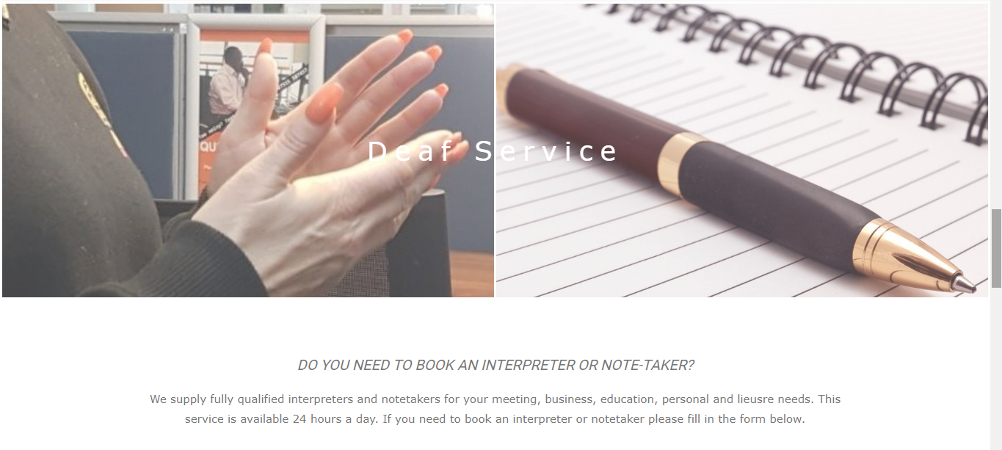

1. Deaf service page

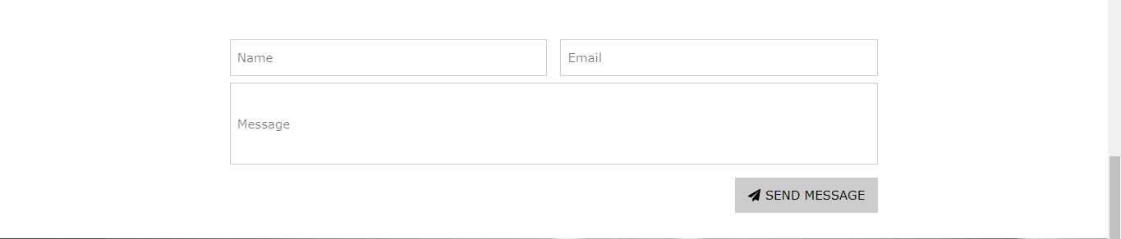

1. Deaf service form

A real life picture of my interpreter and a picture from Google were combined to create one picture. Underneath there is information on how to book an interpreter or note taker. A button will be clicked to show a form to fill in to book an interpreter or note taker. Here a direct link will be created to The Deaf Agency, permission was granted from this company to include their name in the prototype website and demonstration thereby adhering to legal protocol as stated in the interim report.

The forms will be linked to a database. A more in depth database will be created in the future. This website is unique in its access for Deaf people. It includes three things a film subtitled service, Deaf services to book support and events. Unfortunately, due to time constraints the events component is not available as yet but will be added in the future. The proposed website is unique in that it concentrates on one thing done very well – up to date film subtitled showings in London for Deaf people. The simple forms provided in the Deaf service component are quick and easy to use.

Some issues arose with my form which could not connect MySQL. The web server needed to be installed on the computer but stopped working when things were added and disallowed access to the database. Hopefully, this issue will be resolved before demo day.

### Source Code

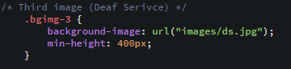

1. Background image code in Deaf Service page

There are three images which include cinema, interpeter (my own picture) and a notepad, that combined into one image by using www.photojoiner.net and this was used for background. Again size was changed to 100%.

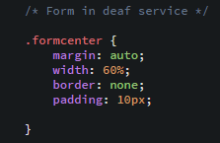

1. Form CSS code in Deaf Services

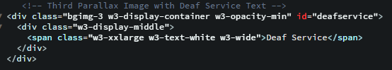

1. Deaf Services Code

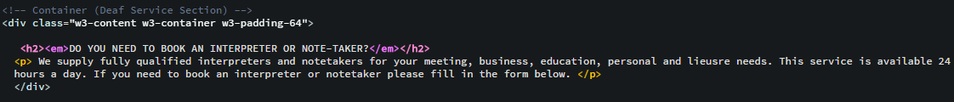

1. Deaf Services Code

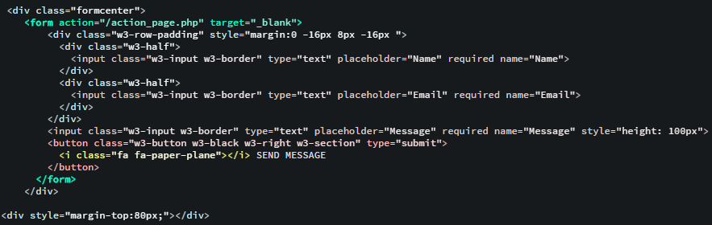

1. Form code in Deaf Service

## Contact Us

The picture was created using Pexel.com Also a feedback form on how to improve the website was added. A small form was used for this process providing the University of East London address and a map from Google. All were created by using the W3schools website. The footer supplies social media links including Facebook/Instagram/Twitter\/LinkedIn. There is a ‘To the top’ button and when clicked upon, it takes you back to the top of the page.

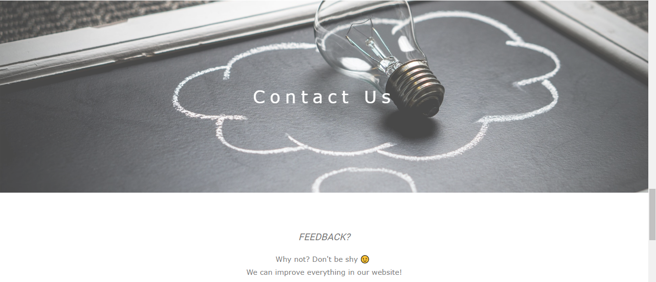

1. Contact Us page

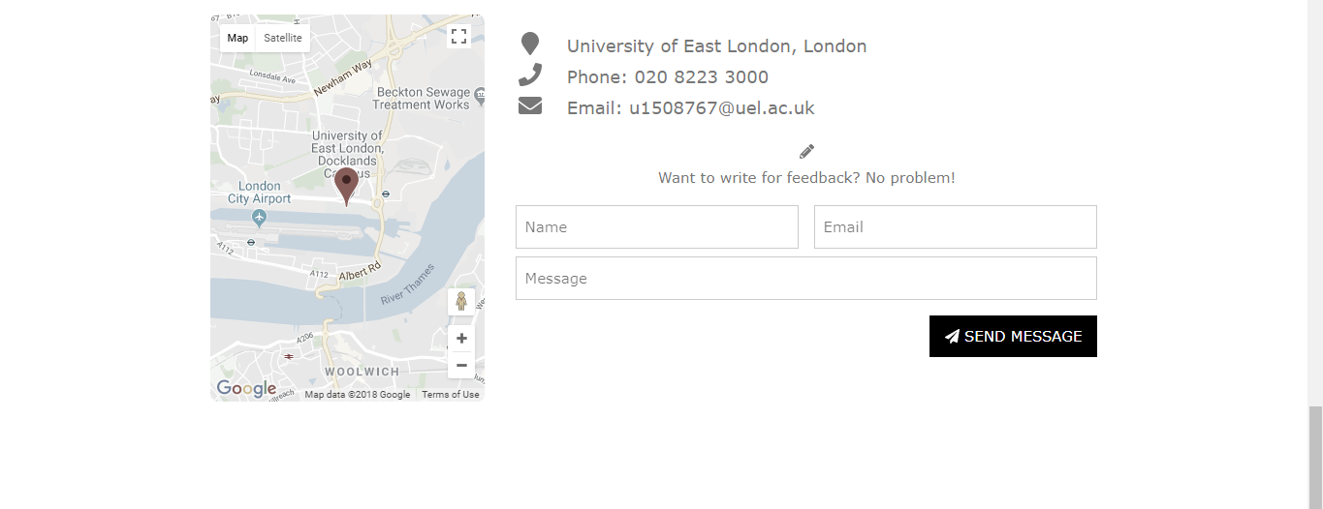

1. Form in Contact Us page

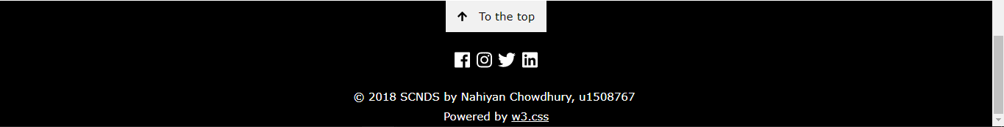

1. Footer

### Source Code

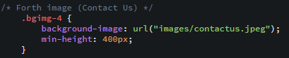

1. Background image code in Contact Us page

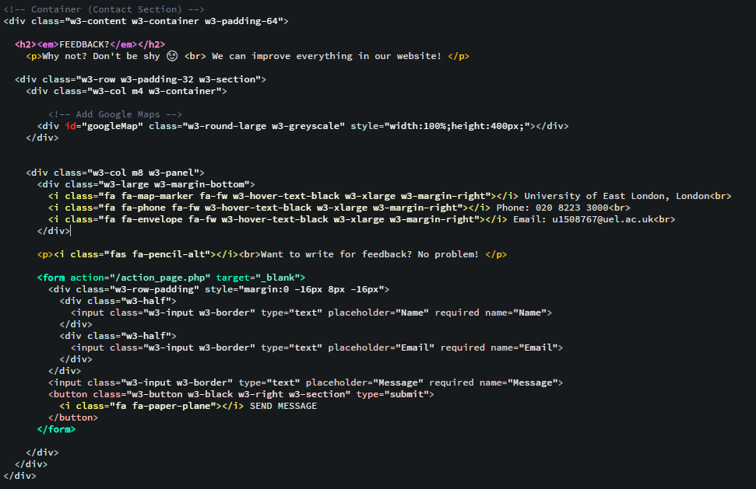

1. Contact Us page code

## Script Code

### Google Map

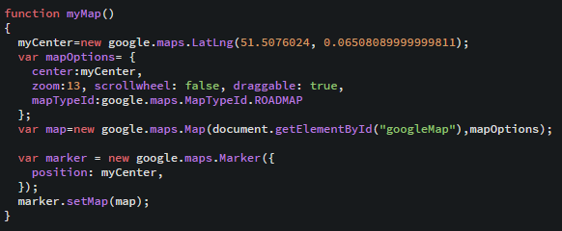

1. Google Map

## Key Functions

Brackets were used to create html and CSS this was to help make it easy to use. These skills were learnt in the first year of the degree.

Photo galleries – W3schools.com

Forms

Creating buttons – menu

Maps – Google

Social Media – icons and links

Background pictures

Functions were kept to a minimum as the proposed websites aim is to be easy to use, Deaf aware and simple. A website for quick information that can be obtained simply, easily and accurately.

## Testing

### Homepage

|  |  |  |  |
| --- | --- | --- | --- |
| **Feature** | **Expected**  **outcome** | **Actual outcome** |  |
| Background picture with titles | The background picture with titles should appear -picture with it. | background picture appears | Successful |
| Background Picture moves | The background picture should move when on scrolling | It moves when it is scrolling | Successful |
| Navigation bar | The navigation bar should work when clicked on the buttons such as Home, Subtitled Cinema, Deaf Service and Contact Us | It works, it jumps to each pages such as Home, Subtitled cinema, Deaf Service and Contact Us | Successful |

### Subtitled Cinema

|  |  |  |  |
| --- | --- | --- | --- |
| **Feature** | **Expected**  **outcome** | **Actual outcome** | **Successful/Unsuccessful** |
| Background Picture moves | The background picture should move when scrolling | It moves when it is scrolled | Successful |
| Eight images of movies | Eight images work | They are working perfectly | Successful |
| Eight images in modal | They should appear when clicking on each image. | It shows up and looks nice and clear. | Successful |
| Click on the title of the movie in the text below each image. (modal) | It should show information about Location and Date/Time of the movie | It shows up and looks clear. It works | Successful |

### Deaf Service

|  |  |  |  |
| --- | --- | --- | --- |
| **Feature** | **Expected**  **outcome** | **Actual outcome** | **Successful/Unsuccessful** |
| Background Picture moves | The background picture should move when scrolling | It moves when it is scrolled | Successful |
| Type name in the form | It should appear when the name is typed | It works perfectly | Successful |
| Type email in the form | It should appear when the email is typed | It works perfectly | Successful |
| Type email in the form | It should appear when type the message | It works perfectly | Successful |
| Warning sign pops up on the form when one clicks send message without filling in these fields such as Name, Email and message | It should appear and it should say ‘Please fill in this field’ | It appears and it says ‘Please fill in this field’ | Successful |
| Click on ‘send message’ button | It should refresh when clicked on ‘send message’ button and should store the information in the database. | It doesn’t work because I cannot access the web server so I do not have time to set up the database. | Unsuccessful |

### Contact Us

|  |  |  |  |
| --- | --- | --- | --- |
| **Feature** | **Expected**  **outcome** | **Actual outcome** | **Successful/Unsuccessful** |
| Background picture moves | The background picture should move when scrolling | It moves when it is scrolled | Successful |
| Click on ‘send message’ button in the form | It should refresh when clicking on ‘send message’ button and should store the information in the database. | It doesn’t work because I cannot access the web server so I do not have time to set up the database in Deaf service and Contact Us. | Unsuccessful |
| Google Map | It should appear and show where the address is. | It shows up and works perfectly. | Successful |

## Solved Problems

|  |  |
| --- | --- |
| **Problems** | **Solved** |
| In the Contact Us page, the picture background did not move when scrolling. | Missed the image code for example, Bgimg-4, so this was added and tested if it moved |
| Google Map has something that went wrong. | I realised that I hadn’t signed up for getting API key so I had to sign up. I copied and pasted the code of API key. It works well. |
| One image was missing in the Subtitled Cinema page. | I put the wrong type of file in the code by mistake. |

## Tools and Techniques

These are the tools and techniques I used- Brackets which is an open-source project making it easy to design the website in HMTL, CSS and JavaScript and understanding the web design. This makes it easier for text editors to enjoy writing code.

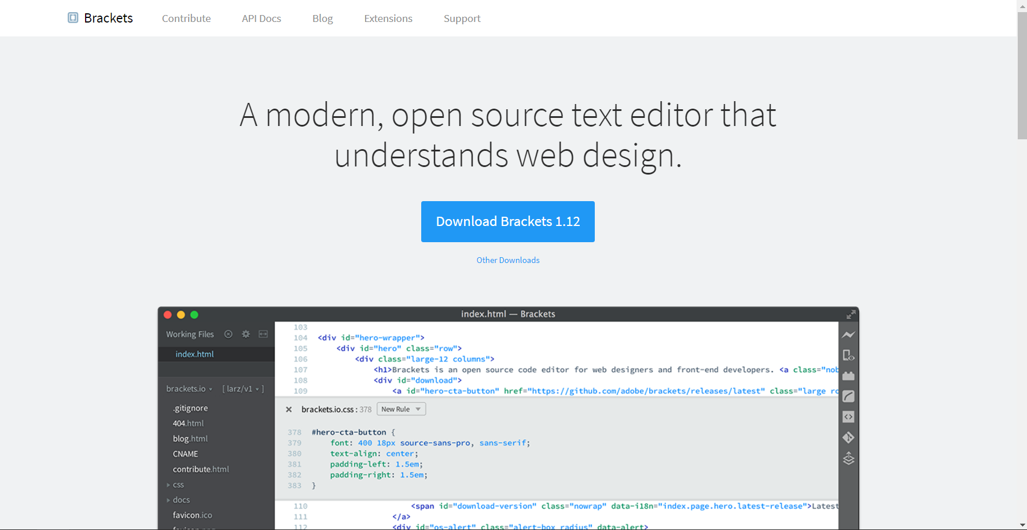

1. Brackets (http://brackets.io/)

## Positive and Negative aspects of Implementation

The positive parts of the proposed website included the photo merge, maps, forms and film advert function.

Negatives were sizing problems, the possibility of translating the website to a mobile phone app – this was not needed as later realised. The colour choice could be amended as it may be an issue for people who are colour blind.

Plans for the future include making this website accessible for Deafblind clients and those with Ushers syndrome.

The proposed website has been estimated at 80% successful so far. The next step will be to develop more skills around PHP and much better links to a database system.

## Surveys

The survey design focused on a specific core group – Deaf people. A shared use of Deaf culture and how it is used to cope in a hearing world informed the choice of questions. Simple questions and short but brief open questions regarding how they used other websites and what let them down. The fact that myself and my Deaf friends have always downloaded films at home encouraged my use of this survey. Deaf people rarely use the cinema and it is such a shame that they are excluded to a certain extent from such a social and exciting event. A film can completely change your mood and is a way for Deaf people to switch off and relax yet it is something many feel totally excluded from. The survey below explains why this is a problem told by Deaf people who want and try to use the cinema.

The survey was successful, Survey monkey website was used to create this. It was a very useful tool to obtain Deaf people’s opinions. The questions were aimed specifically at Deaf people’s use of cinema. From these questions a pie chart diagram was created to display the findings.

Please see the results in the Appendix F.

# Evaluation

In evaluating my work a view of how it will be used by other Deaf people had to be taken into account at all times. As stated earlier this may mean purposely making things simpler as this is the audience the website is aimed at, a Deaf audience whose second language is English rather than complicating things. Simplicity of the language is paramount as is a clear and simple lay out that is visual rather than aural and totally Deaf aware.

The project was aimed at a Deaf audience to improve their enjoyment of cinema viewing. Please take into account that even though Deaf audience has definite overlaps in the hearing world they are a culture of their own making also. Deaf clubs and pubs exist where the only form of communication here is sign so that Deaf people can relax and network in their own language. They are a great experience for a hearing person to visit and see how it feels to not understand what everyone is communicating about! Here lots of ideas around new technology or useful websites are spoken about and ideas exchanged. Therefore my surveys and website must be adjusted to appeal more to Deaf people. This was at the forefront of my thinking from start to finish in the design process of the proposed website.

The aim was for the listings to be totally accurate. This was successful although there was not enough time to include events for example. Here for future work there will be events linked to Deaf clubs, activity events and social gatherings. The widening of areas to be covered to include outside of London or even national listings. The Deaf service part makes it easier for access to book interpreters as Deaf people do not use the phone. The proposed website is user friendly and most importantly quick. There are some successful and unsuccessful features here.

The successful features are: -

Background images: - four images used for background in each page such as the homepage, Subtitled Cinema page, Deaf Service page and Contact Us page. These images will move when on scrolling.

Images: - There eight images used of movies in Subtitled Cinema page. People can click and view the images when it appears.

Map: - Google Maps was used in the Contact Us page- it uses UEL, University of East London that shows people where we are.

Social network icons: - Four social network icons in the footer. They are used to link UEL to social networks.

The unsuccessful feature is: -

Database (the forms in Deaf Service and Contact us): - Database was not used in the SCNDS website because it had some issues-Decided to remove the codes because it could confuse the website. In the future or after the demonstration, hopefully there will be time to add the database.

The proposed website combines two services in one, a film subtitled listing service and a service to book interpreters which is quick, easy and accessible, this then gives people direct access to what they need. There is no need to use phones or to ask a family member or interpreter to call for them. The amount of information provided on my website is relevant and to the point. In this evaluation of other websites there was too much information on there. The websites were trying to do too much and involved complicated English language and linguistics which would put Deaf people off.

## Problem

As the proposed website developed there was a glitch which lasted a couple of days where resolving it was taking huge amounts of time. Google research was used to fix problems and also problems around not having the correct passwords or keys. The contacts page needed the correct API key. Other problems arose around the login page- google maps, java script and API. I used the customising tool with maps to customise content and imagery for display on the website and mobile devices. It featured four basic map types, road, satellite, hybrid and terrain which can be modified using layers and styles, controls and events and various services and libraries.

Background pictures would not move which I discovered was due to the wrong copying of code. On discovery of the fore mentioned mistake it finally moved. Mistakes also came to the fore in pictures regarding JPEG. This was due to moving it to the wrong file which was finally resolved.

All buttons work successfully and 80% of the aim to achieve in the initial plan has been achieved. Overall the results match the interim report; also the aim of my implementation has been achieved. These include working buttons, background pictures complete and moving, images moving downwards when clicked on, when a film is chosen and clicked on the information appears, maps are working well and the links for social media are all working correctly. The forms linking to the database have had some technical issues but they should be working before the demonstration day. Templates, wire frame, font awesome and Bracket were used in the creation of this website. On my original project plan the aim was to include Deaf events, this has not been achieved due to time constraints but will be added in the future.

This website was tested out on some of my Deaf friends and the users found this website easy to access compared to other websites they had previously used, they liked the fact that it was two services in one. Booking an interpreter function they found easier than usual as it provides a simple form with a direct link to an agency, rather than using the phone or asking family or friends to assist them and also they really liked the subtitled film service. Deaf people prefer to use facetime or webcam with regards to communication as it is visual, this is a function that is an aim for future development.

Research into other similar websites proved to show a need for the proposed website. The only similar websites that were found also included a lot of other information regarding Deaf issues. There were no direct links to booking an interpreter or note taker provided. The subtitled film showings were extremely difficult to find hence the reason this website was chosen in the first place due to my own personal experiences. There is no other website such as the proposed website available at this moment in time. The aim of this website is to alleviate some of the stress involved with these issues and close the social exclusion gap. This hopefully will give users a much nicer experience in accessing the latest films available at the cinema and also booking an interpreter or note taker.

# Conclusion

In conclusion the uniqueness of this website application is that it is a website created BY Deaf people FOR Deaf people. Tools, strategies and surveys were all aimed around it being created for people with very different communication needs to hearing people and to close the access gap between hearing and Deaf worlds.

Ideas for future work will be to add an EVENTS part to my website, cover areas providing subtitled films outside of London, provide more links to other companies to provide information and Deaf services and to possibly add a NEWS feature and links to social media/ blogs. Eventually this website can be turned into a mobile app. Here I want to extend my knowledge much more deeply into java script. As stated earlier Deaf people love the live chat feature of websites such as 02 or Barclays Bank as they do not need an interpreter to relay information so this is definitely an idea to think about in future work. Also a live facetime feature. Deaf people make up a huge proportion of facetime users as they can sign on screen. The new fashion of larger sized smart phones has made this feature even more useable.

The creation of this website highlighted a definite need for a website such as this. The research that was carried out above shows how this was done. It defined the gap that still exists where Deaf people are still blocked from enjoying the leisure facilities such as film that hearing people take for granted. Research included personal experience, websites, journals, articles and surveys. The key to access in a Deaf world is always communication and the different ways of getting around this problem. These ideas are what was focused on during the process of creating this website. During its creation simplicity, visual thinking, lack of long complicated English sentences and questioning how and why Deaf people use websites in the way that they do, enforced the vision and the design.

The Deaf world is a pretty undiscovered area in terms of what could be accomplished in the future regarding technology, websites and apps. The difficulty here lies in the fact that Deaf people are not considered to be a target business audience so the money making possibilities of them is limited and lots of the funding for Deaf work is through government funding. Considering there are 10 million Deaf people in the UK this film subtitled service should be in high demand.

As stated earlier my future work will contain lots of possibilities in this area as technology grows. For my own website interactive features, live chat, cinema listings outside of London and a separate features page with news and events are all possible. Also direct links to interpreting agencies, links to other Deaf companies and websites, advertising and possible ways to make money by getting a cut of clients referred to agencies through my website.

.

References

*BSL History* Available at: <http://old-bda.org.uk/What_We_Do/BSL_History> (Accessed: 28 March 2018)

Harlan, L. (2005) *‘Ethnicity, Ethics and the Deaf-World’, The Journal of Deaf Studies and Deaf Education,* Volume 10, Issue 3, (1 July 2005), pages 291-310.

*Equality and Human Rights Commission* Available at: <https://www.equalityhumanrights.com/en/multipage-guide/three-requirements-duty> (Accessed: 26 March 2018)

Legislation.gov.uk (2010) *EqualityAct2010*

*ReDeafined* 29Nov2012. Available at: [http://www.reDeafined.com/2012/11/update-sony-subtitle-glasses-review.html](http://www.redeafined.com/2012/11/update-sony-subtitle-glasses-review.html) (Accessed: 9April 2018)

*Subtitled Cinema and Me.* Available at [https://Deafunity.org/article-interview/subtitled-cinema-me/](https://deafunity.org/article-interview/subtitled-cinema-me/) (Accessed 9 April 2018)

*The Equality Act* (2010) Available at: <https://www.legislation.gov.uk/ukpga/2010/15/section/20> (Accessed: 9 April 2018)

*The Three Requirements of the Duty.* (14 April 2016) Available at: <https://www.equalityhumanrights.com/en/multipage-guide/three-requirements-duty> (Accessed: 9 April 2018)

*UK Statistics and Facts* <https://www.disability.co.uk/sites/default/files/resources/UKStatistics%26Facts.pdf> (Accessed: 4 March 2018)

*What we do/BSL History* (2018) Available at: <http://old-bda.org.uk> (Accessed: 5 April 2018).

*Your Local Cinema* Available at: <http://www.yourlocalcinema.com/explanation.html> (Accessed: 9 April 2018)

Appendix A - Initial Project Proposal

Project (CN6103) Initial Proposal Form

Programme: Computer science Year: 2017

Semester: Term 1

Student Number: u1508767

Proposed Title: Deaf Website

Proposed Aim:

(Please provide a brief summary of what you hope to achieve by the end of your project. Your proposed aim should clearly identify your topic of interest.)

I will aim to create a website for Deaf/hard of hearing and hearing people. I will add subtitled cinema events, book an interpreter or note taker. The aim will be to help Deaf people find suitable subtitled events in the country so they can communicate. I think both Deaf and hearing people will be interested in my project idea. So when some people want to book an interpreter/a note taker on the website online it will be quick and simple. It will provide a direct email service to the company Deaf Agency which is an interpreting agency.

Rationale:

(Please provide a detailed explanation of why you think this project needs to be undertaken.)

I feel this subject needs to be undertaken as I am a partially Deaf man so have a good knowledge of what needs to be done in this area. My idea is to create a website where Deaf people can log on and find what cinema or events in London are on that contain subtitles so that they can understand what is happening.

So my website will:

* Contain Subtitled cinema places with dates and times
* Local cinema that are showing the films with a map tool
* Events that can be either subtitled or interpreted
* Theatre events that can be interpreted
* Mosque services that can be interpreted
* Links to Deaf agencies. Services and the RNID
* Deaf trained driving instructors
* Possible news feed

Check if similar websites are already available?

I have been checked some similar website. There has few Deaf websites that Deaf/hearing people use these websites for checking some movies and events.

Look at below these websites:

* [http://www.royalDeaf.org.uk/](http://www.royaldeaf.org.uk/)
* <https://bda.org.uk/>
* <https://www.actiononhearingloss.org.uk/>
* http://www.yourlocalcinema.com/ (cinema)

What are strengths and weaknesses of existing Deaf website?

The strengths are:

* Find the events
* Find the cinema which has subtitled movies
* Book an interpreter

The weaknesses are:

* Too hard to find the cinema has subtitled (for example, when you find the subtitled movie on Vue, Cineworld and Odeon official website but they don’t show up like 'S' subtitled)

What is special about your website?

Deaf/hearing people will find the cinema which has subtitled movies in my website so it helps them to go to the cinema in London area. They will find the events like drama, paintball, fun games and more. Also, they want to book an interpreter for meeting.

What tools/software do you intend to use?

I am not sure because I have not started to creating websites. I was thinking about how to design the website. I have started sketching this week.

Supervisor: Aloysius Edoh

Appendix B - Final Project Proposal

Project (CN6103) Initial Proposal Form

Programme: Computer Science Year: 2017

Semester: Term 1

Student Number: u1508767

Proposed Title: Deaf Website

Proposed Aim:

(Please provide a brief summary of what you hope to achieve by the end of your project. Your proposed aim should clearly identify your topic of interest.)

I will aim to create a website for Deaf/hard of hearing and hearing people. I will add subtitled cinema events, book an interpreter or note taking service. The aim will be to help Deaf people find suitable subtitled events in the country so they can communicate. I think both Deaf and hearing people will be interested in my project idea. So when some people want to book an interpreter/a note taker on the website online it will be quick and simple. It will provide a direct email service to the company Deaf Agency which is an interpreting agency.

I have checked some similar websites. There are a few Deaf websites that Deaf/hearing people use these websites for checking some movies and events.

Look at below these websites:

[http://www.royalDeaf.org.uk/](http://www.royaldeaf.org.uk/)

<https://bda.org.uk/>

<https://www.actiononhearingloss.org.uk/>

<http://www.yourlocalcinema.com/> (cinema)

I found some strengths and weaknesses of existing Deaf website.

The strengths are:

* It finds the events
* It finds the cinema which has subtitled movies
* Book an interpreter

The weaknesses are:

* Too hard to find the cinema which has subtitled films and when you do find the film the ‘S’ is not a subtitled film so there is a fault in the web design.

Deaf/hearing people will find the cinema which has subtitled movies in my website so it helps them to go to the cinema in the London area. They will find events like drama, paintball, fun games and more. Also, they can book an interpreter for a meeting.

Objectives: (Please provide a list of the objectives you need to achieve for your project to succeed.)

I need for my project to succeed to create a website for Deaf people so they can access it for checking cinema, events and to book an interpreter. That means there will be 3 things involved in one website. I want service users to be happy to use my website because they can access one website so I think they will not need to bother to check other websites or, other events, subtitled cinema and interpreter services at lots of different websites.

Rationale:

(Please provide a detailed explanation of why you think this project needs to be undertaken.)

I feel this project needs to be undertaken as I am a partially Deaf so have a good knowledge of what needs to be done in this area. My idea is to create a website where Deaf people can log on and find out what films or events are on in London that contain subtitles so that they can understand what is happening. It will need to show date, time and where, possibly using google maps.

My website will:

* Contain subtitled cinema places with dates and times and location
* Local cinema that are showing the films with a map tool
* Events that can be either subtitled or interpreted
* Theatre events that can be interpreted
* Links to Deaf agencies. Services and the RNID
* User-friendly
* Easy to use
* Deaf aware
* Three in one service

Facilities required: (Please provide a detailed list of what you will need to do implement your solution)

Facilities required: (Please provide a detailed list of what you will need to do implement your solution)

* Images
* Software
* Map
* Video
* Database

Supervisor: Aloysius Edoh

Appendix C – Project Progress Presentation Slides

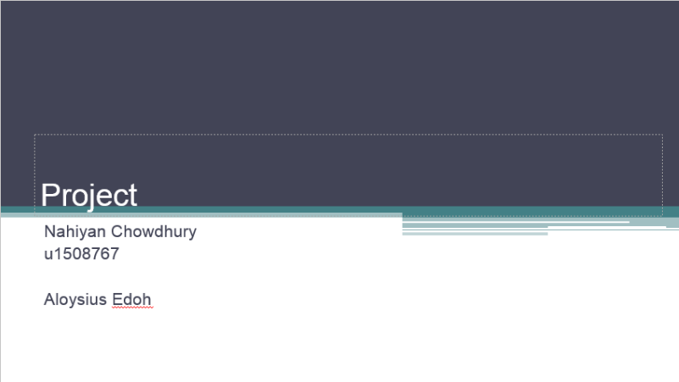

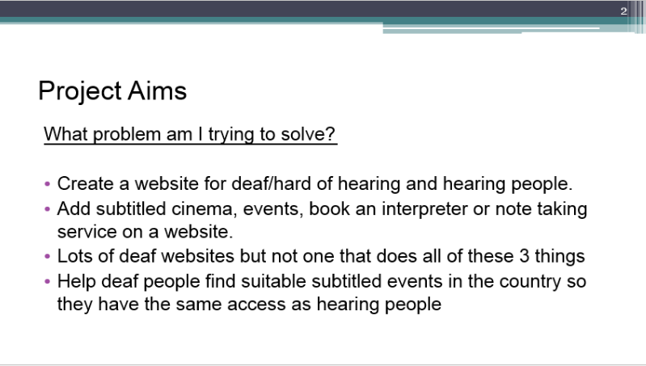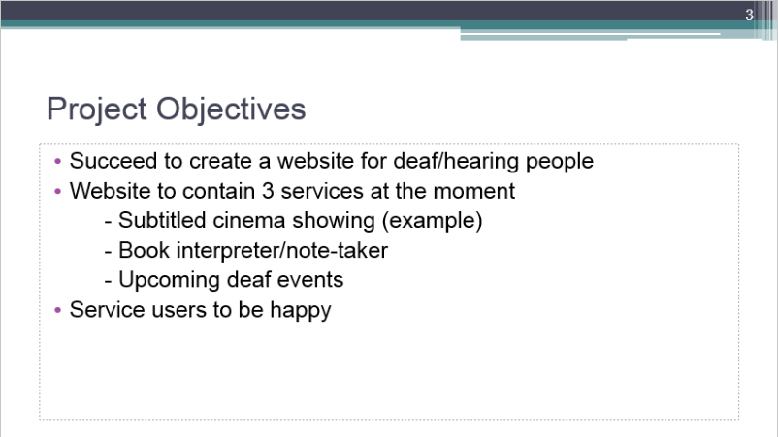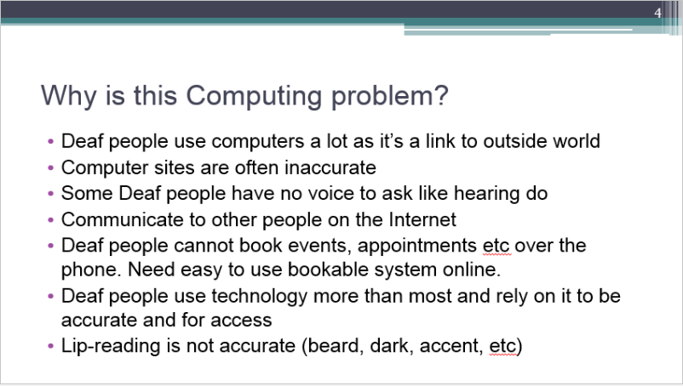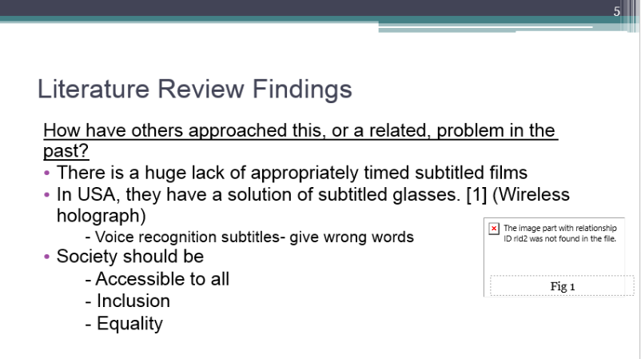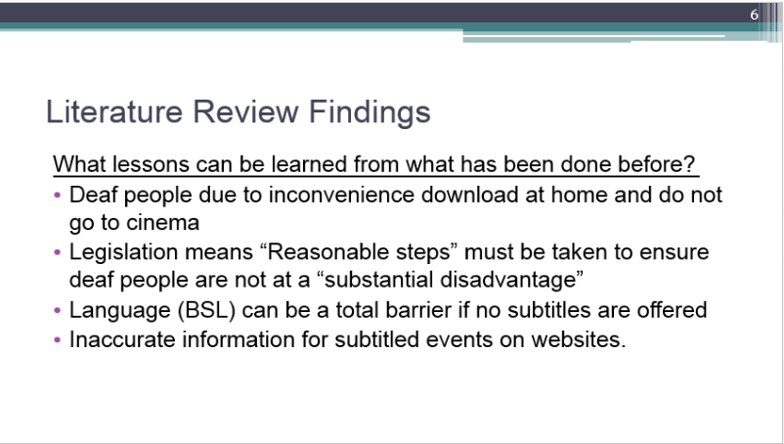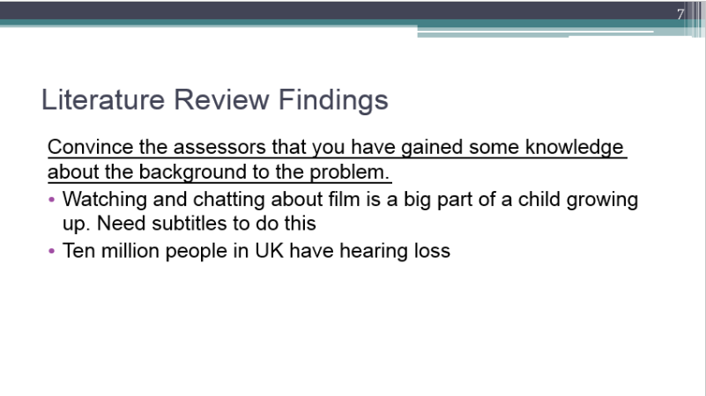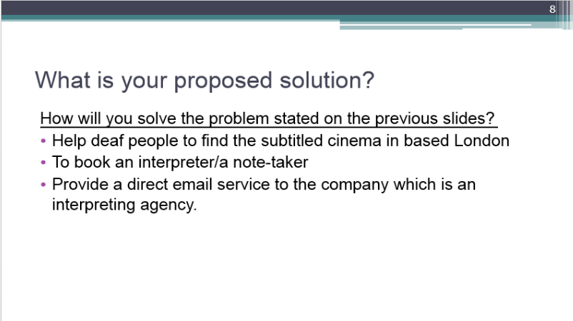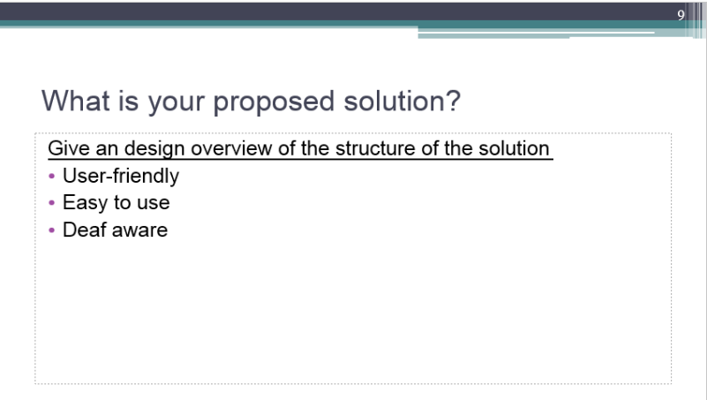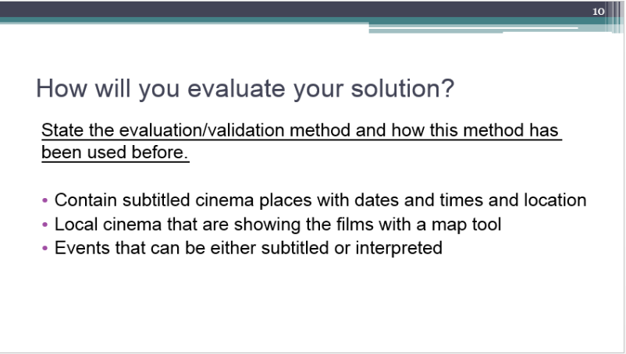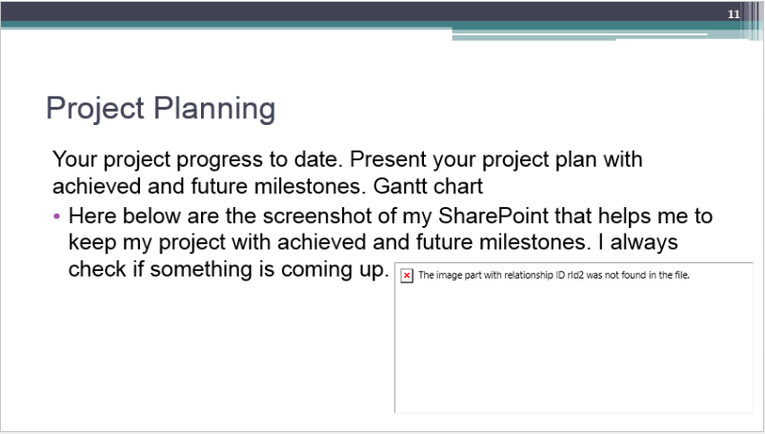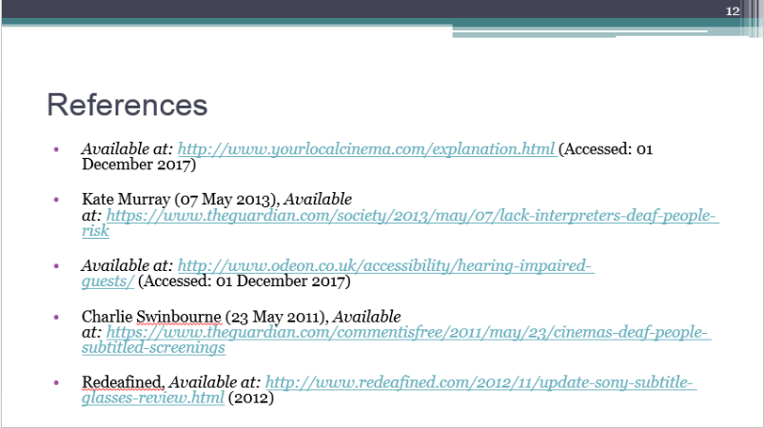

Appendix D – Project Planning

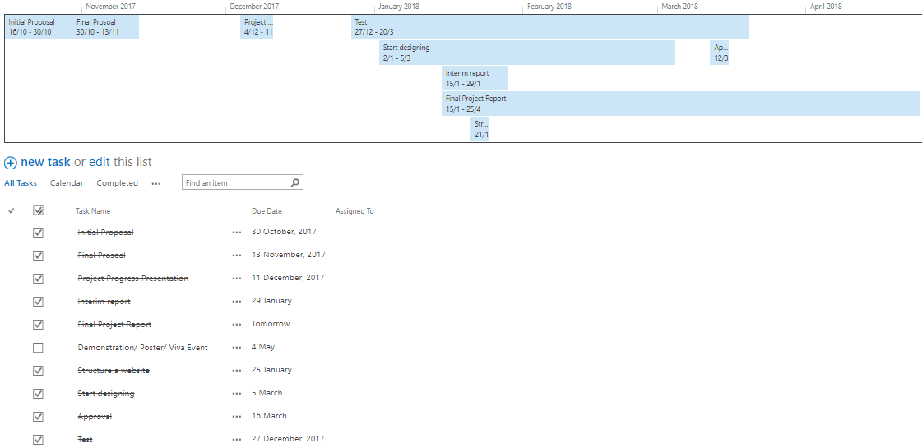

1. Project Planning Gantt chart

Appendix E – Survey Results

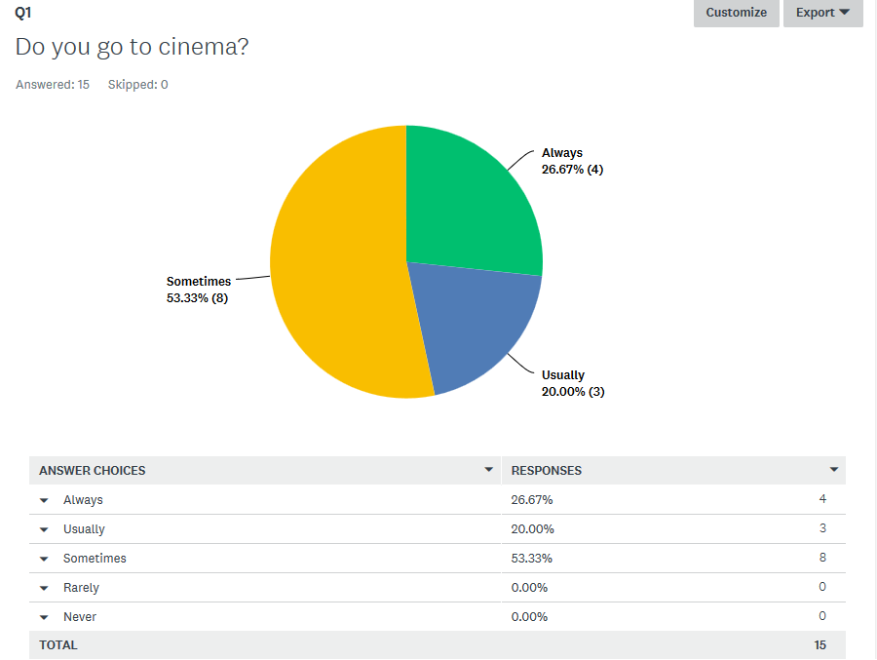

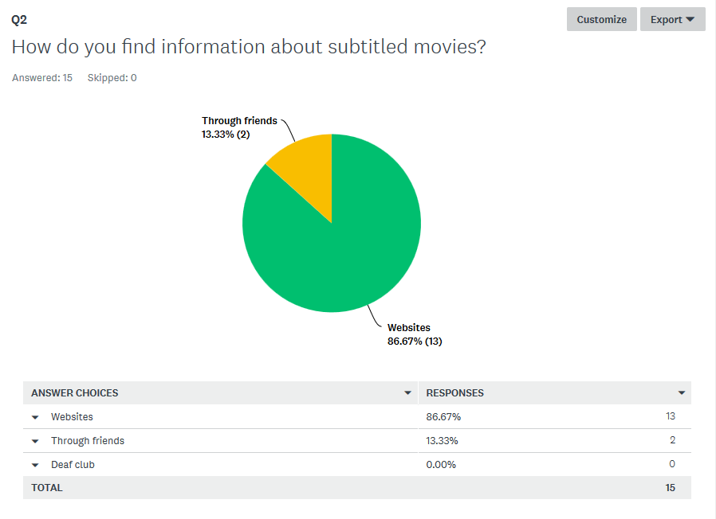

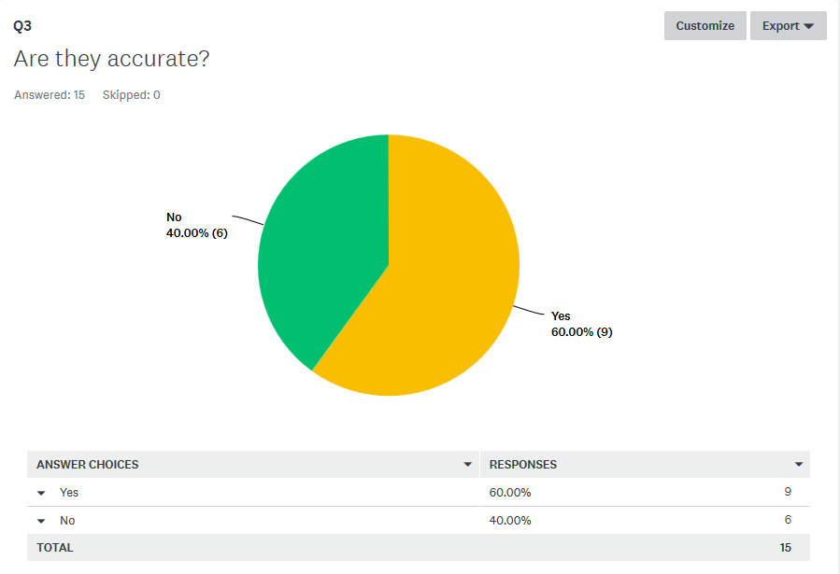

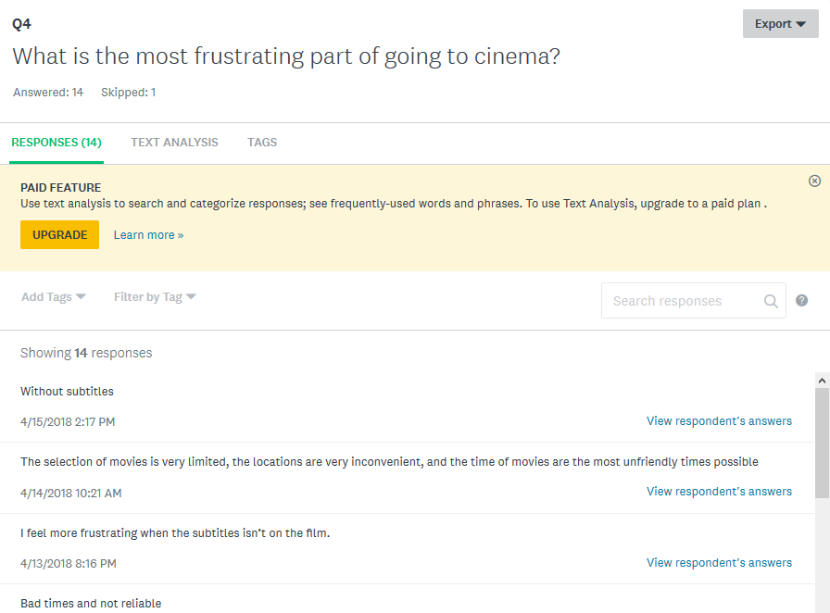

** Please note – This survey was filled in by Deaf people and may contain some grammatical errors as English is their second language and BSL is their first.

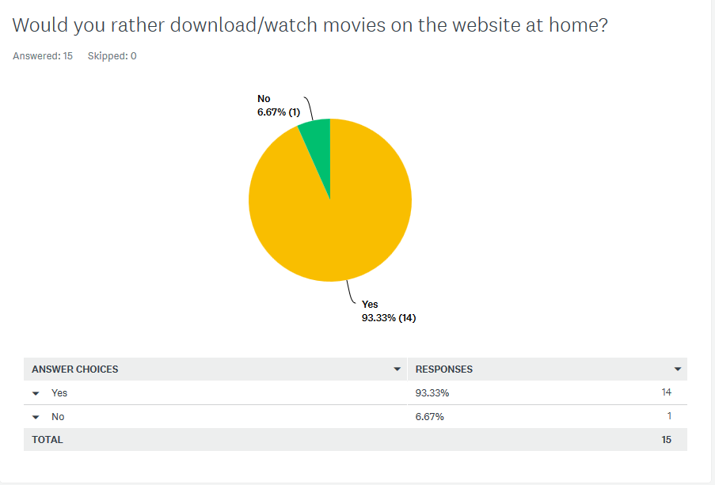 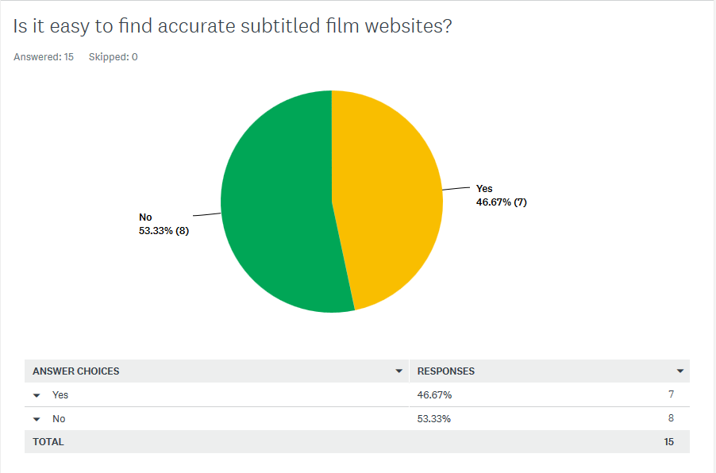 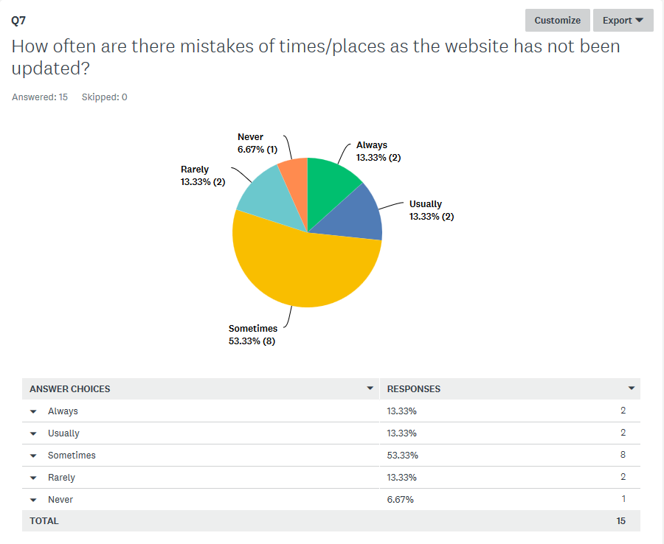

**Appendix F – Project Poster**

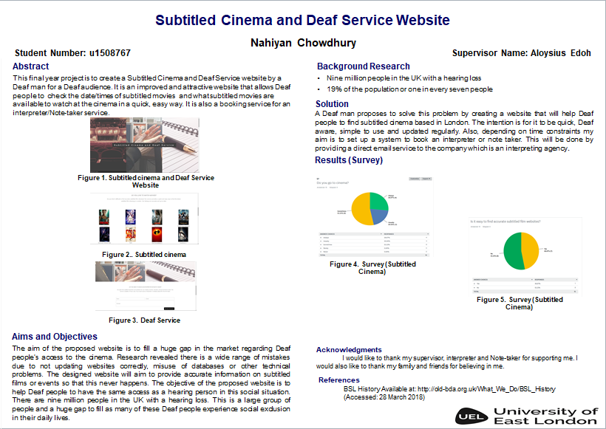

1. Poster